# Lab 14: Creating Data Model in Power BI Desktop

Install and Open a Power BI desktop.

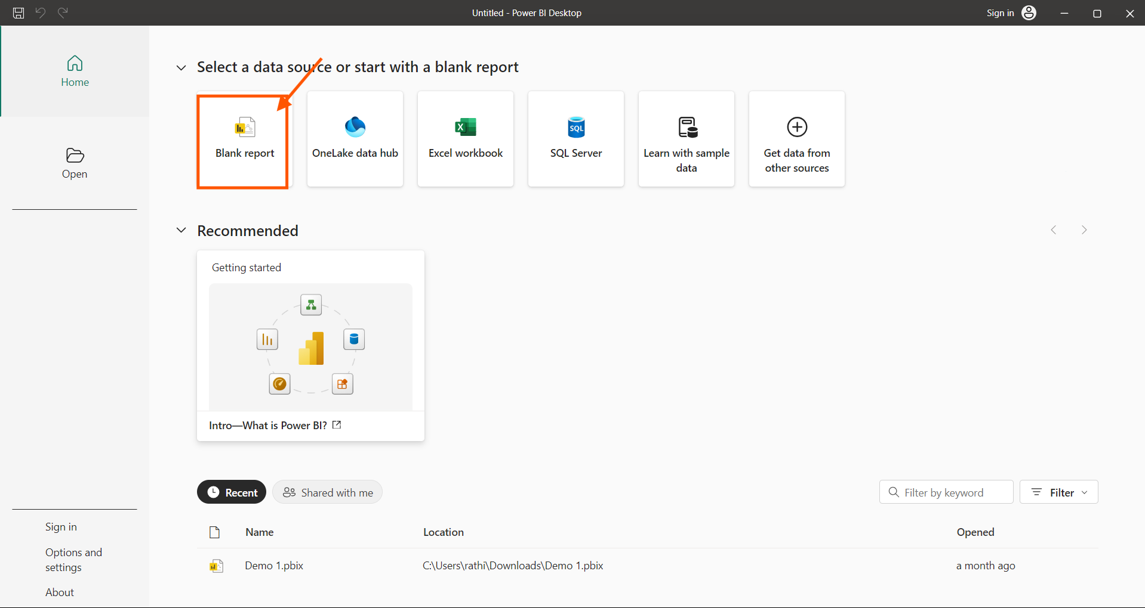

To load the data from the file SF311 calls. Select “Get Data”, Select “Text/ CSV”

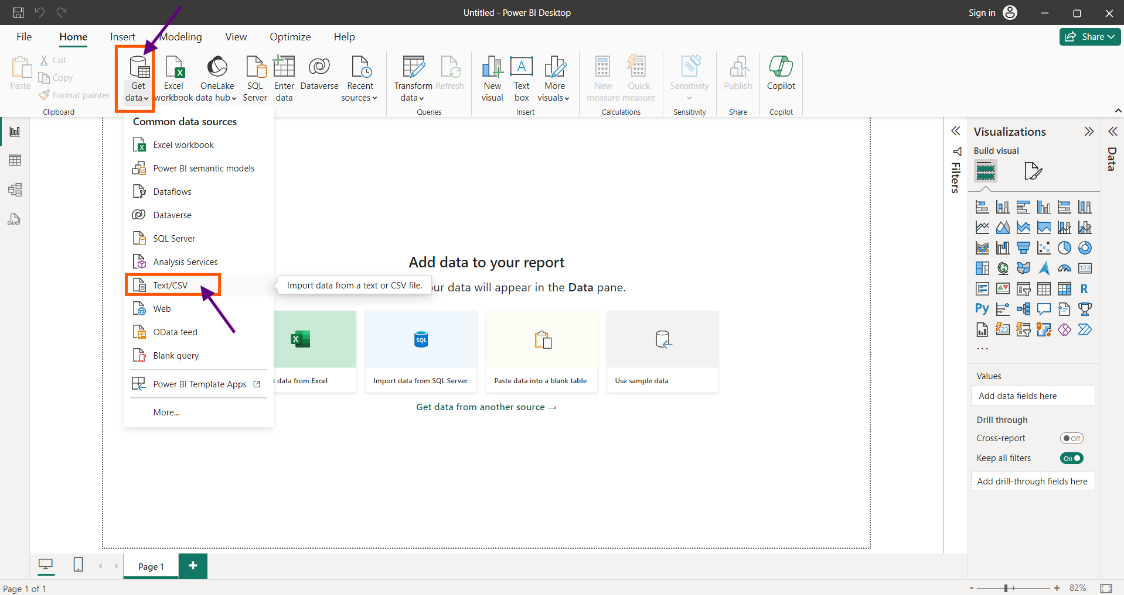

Navigate and Load “SF311Calls” from the PC

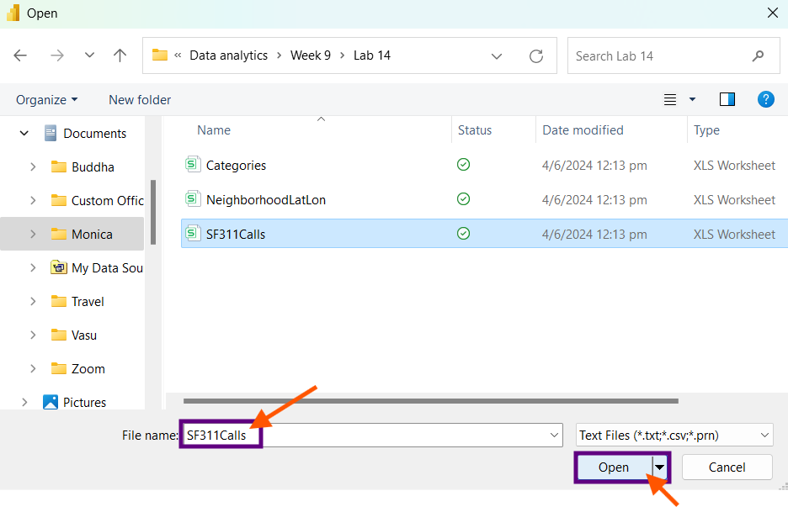

Click “Transform Data”

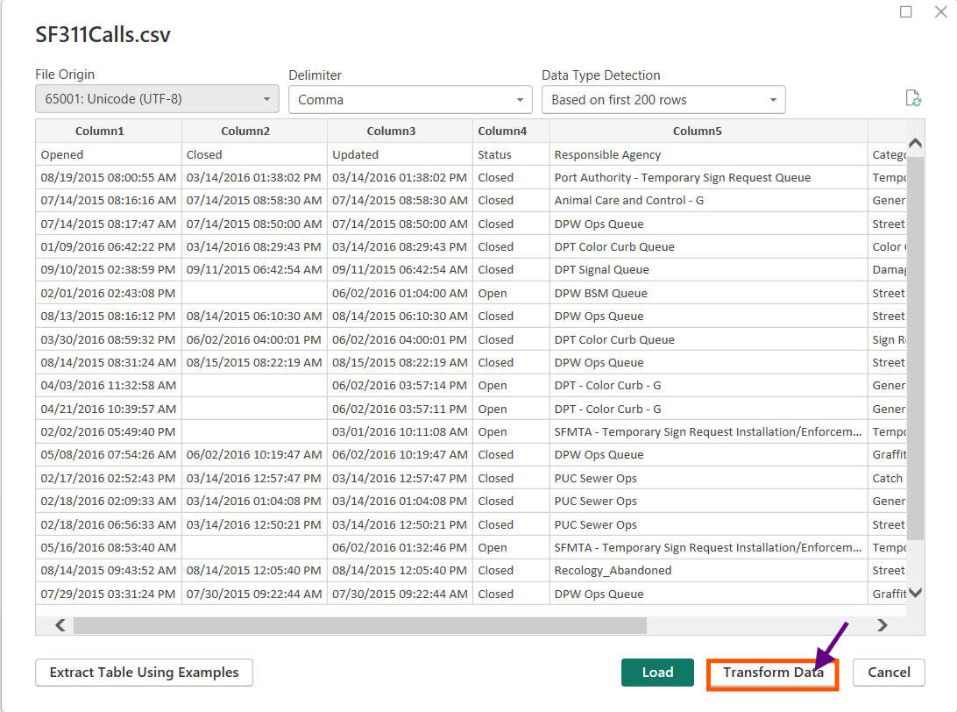

This will lead us to the Power Query Editor in Power BI

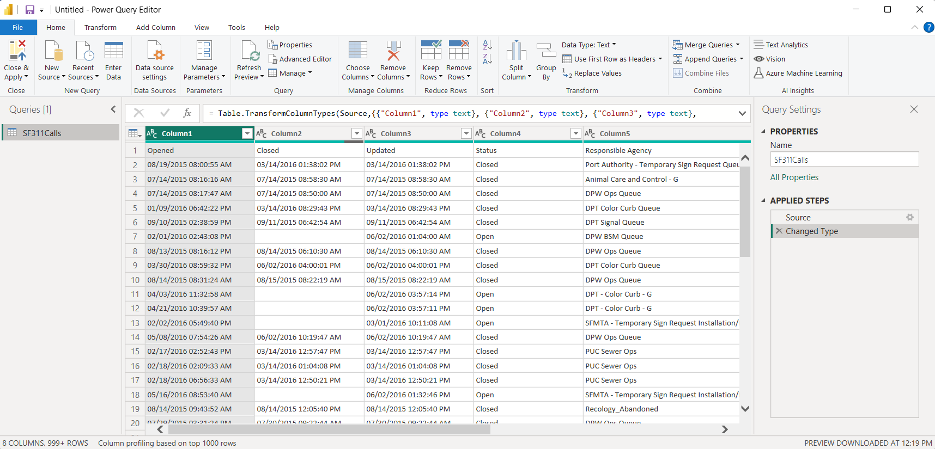

We find the first row of each column are not the column names, to change it to their column names, In home tab select “Use First Row as Headers”

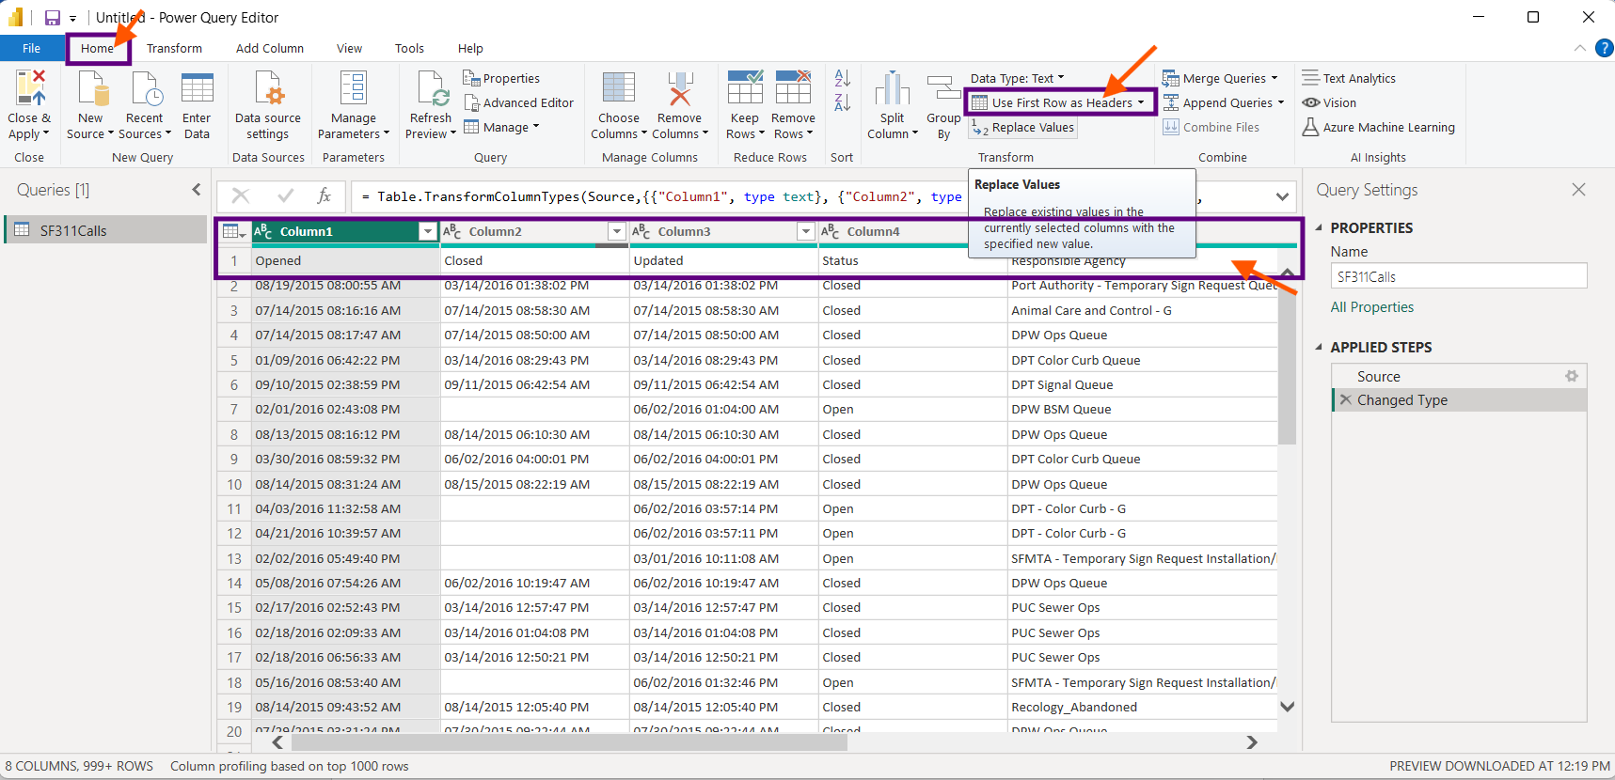

We find the types have been changed after changing the column header. Select “Opened” column, we find Data type as Text. To change the data type. Select the column, right click, select “Change Type”, Choose “Using Locale”.

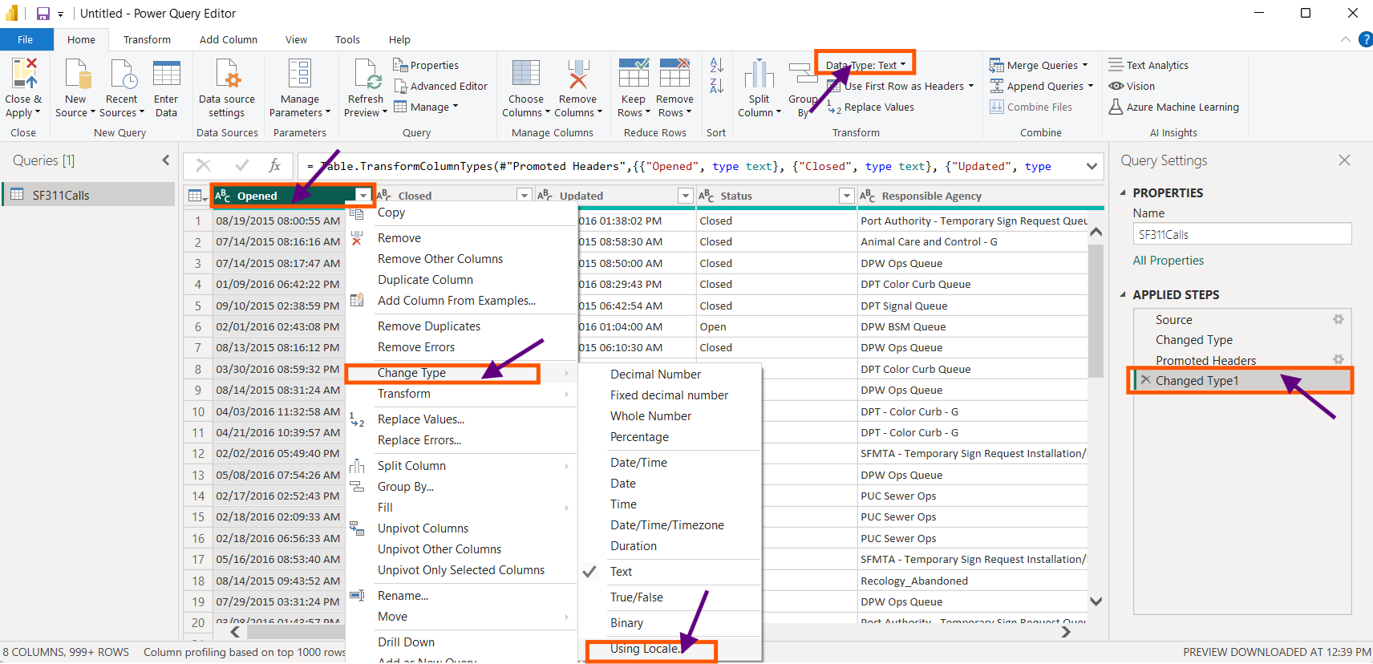

Change the Data Type to Date/Time and Locale to “English (United States)” from the drop down and Press “OK”.

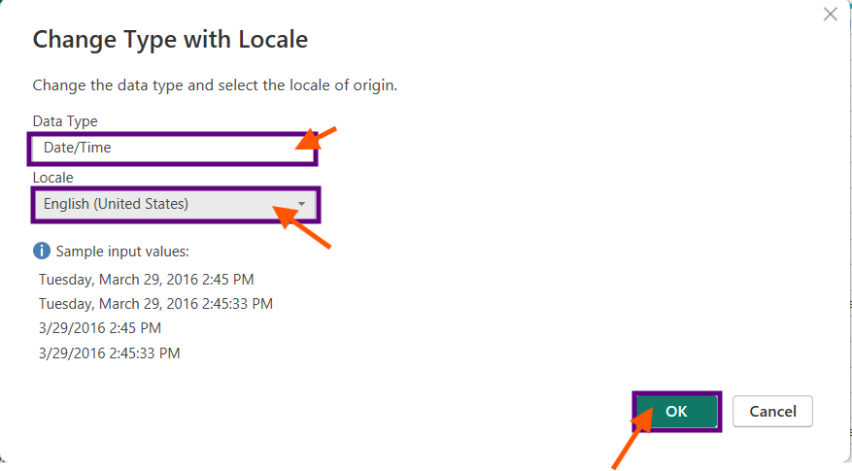

Similarly change the Data type for Closed and updated by selecting both columns together using CTRL key. Select “Change Type” , Choose “Using Locale”.

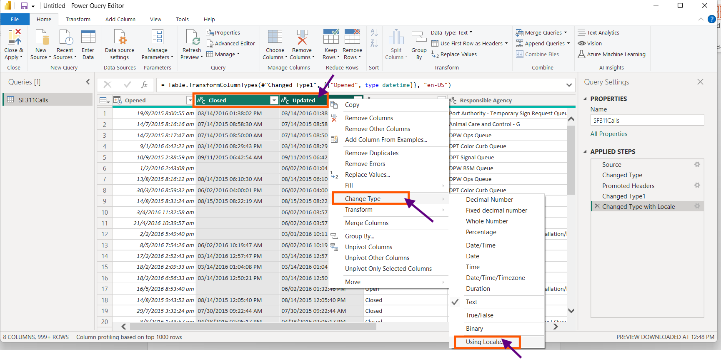

Change the Data Type to Date/Time and Locale to “English (United States)” from the drop down and Press “OK”.

Select the 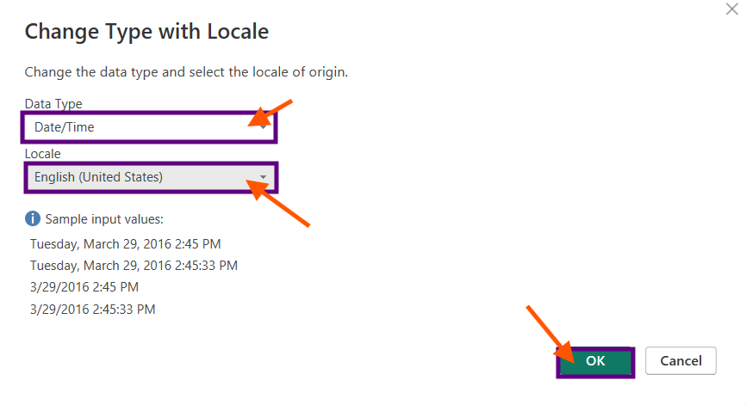

Select the “Responsible Agency” column, Select the drop down near the column header of the column.

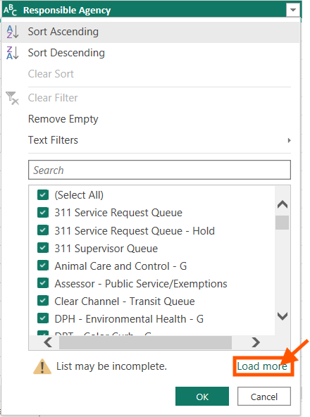

Filter out “Test Queue”, “ZZ RPT” and “ZZ Taxi Commission” from the “Responsible Agency” column.

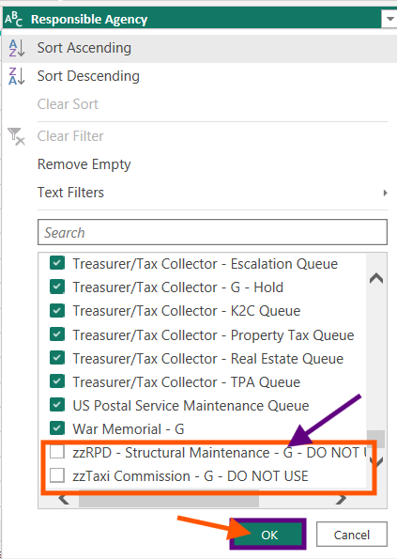

Select the “Opened” column, Select the drop down, Select Date/filter, Choose “After”.

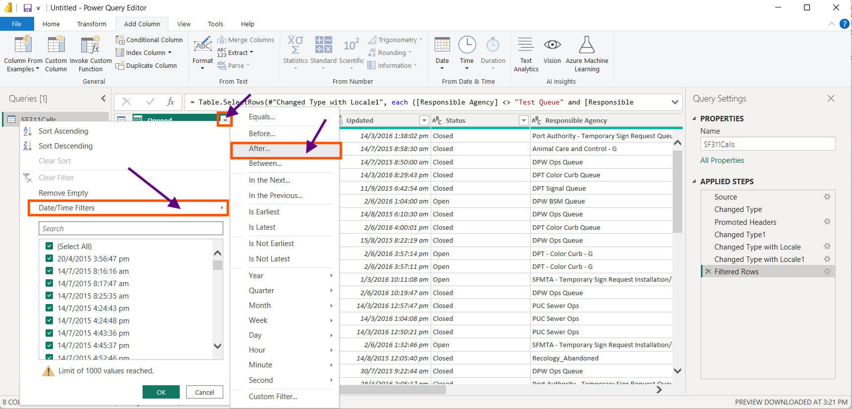

Choose the Specified date 31/12/2014 from the nearby calendar drop down. Press “OK”.

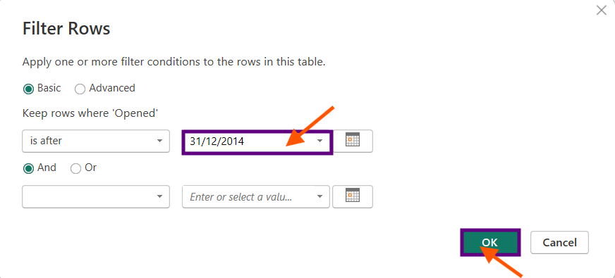

Select the “Opened” column, select “Add Column”, Select “Time” icon, select “Hour”, Choose “Start Hour”. This will create a new column at last with starting hour from “Opened” column.

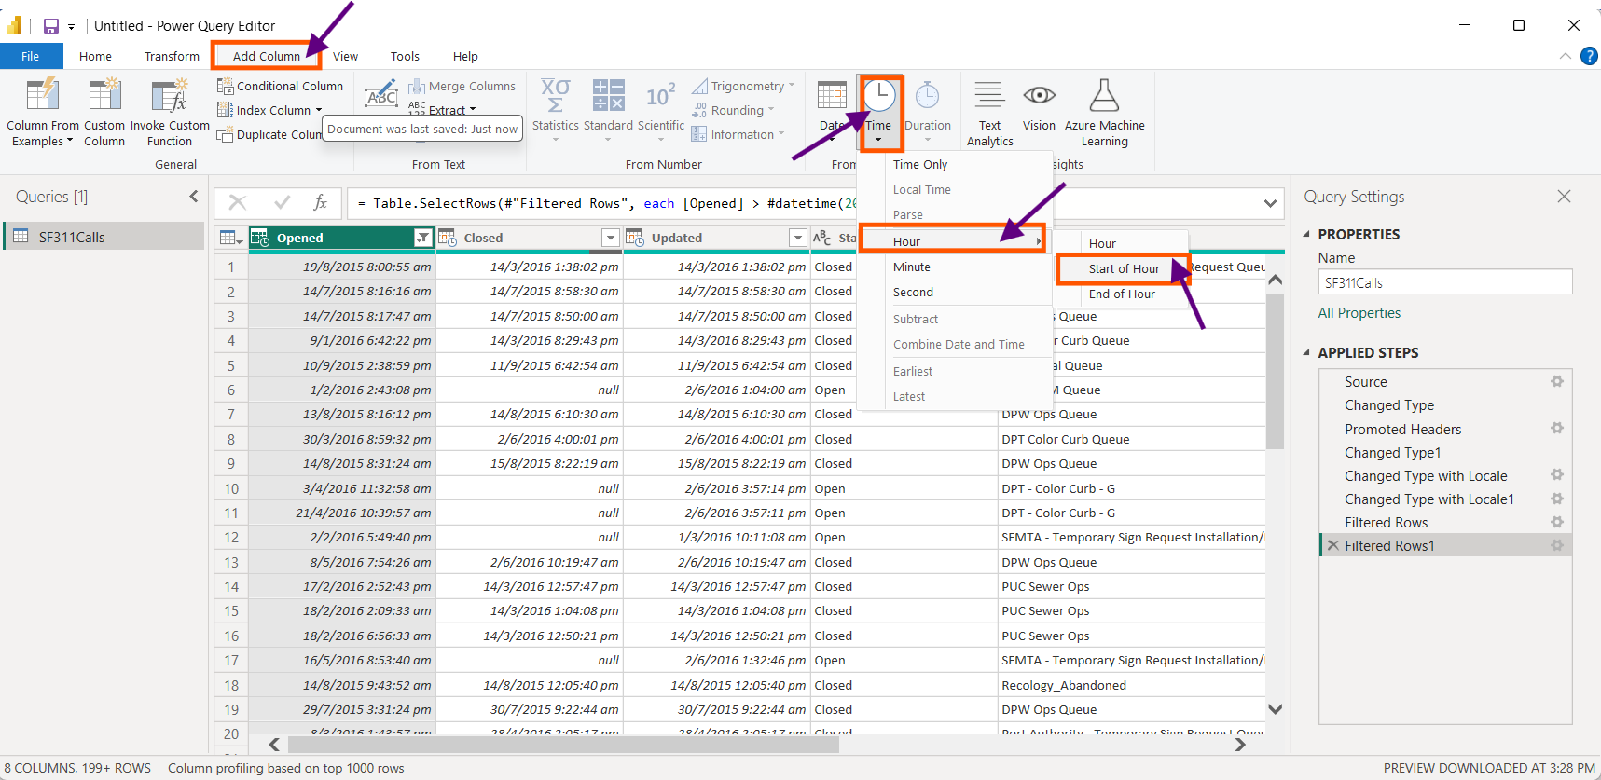

We find a new column opened at the end of all columns as “Starting Hour”. We Rename this column as “Hour Opened” and the type of this column is changed to “Time”. This way we find in the data that the previous column “Opened” is not altered and a new column with only time is created.

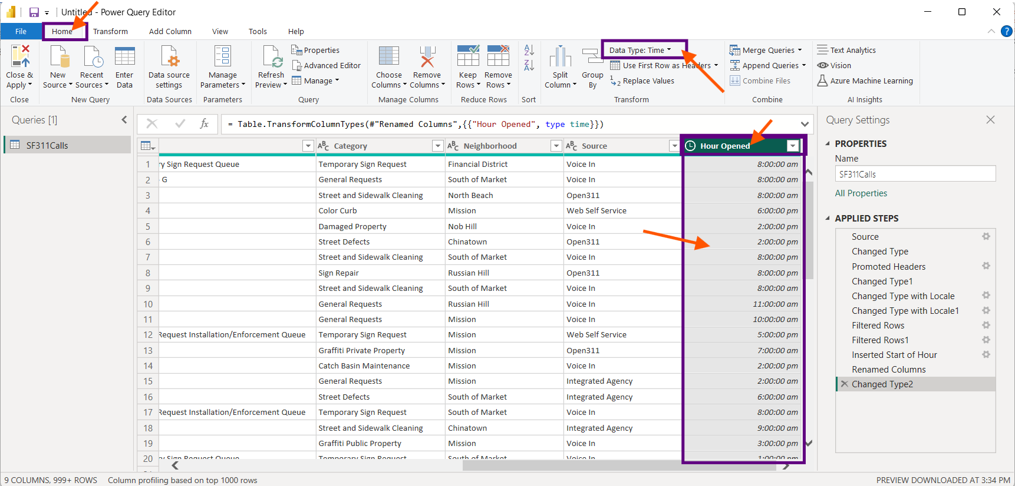

Now In the “Opened” column change the data type to date only by selecting the column, select “Data type” choose Date.

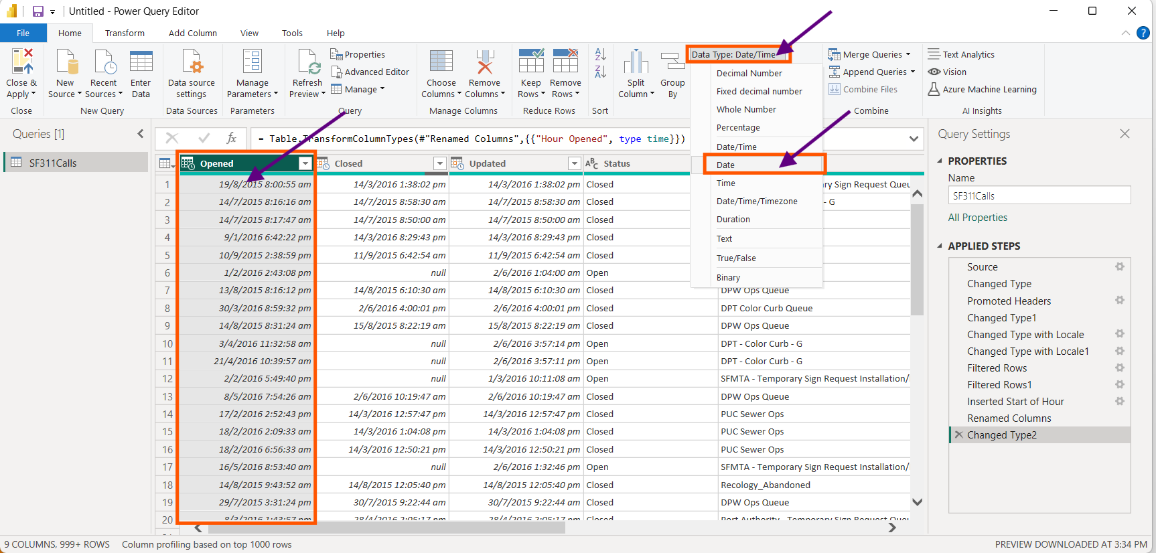

Rename the “Opened” column as “Date Opened”.

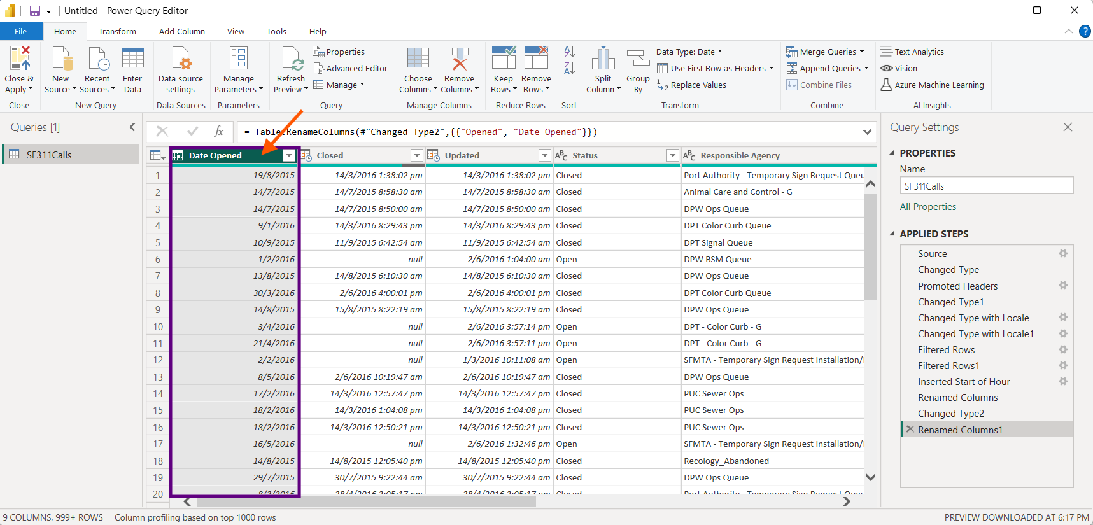

For “Closed” Column just change the data type as “Date”.

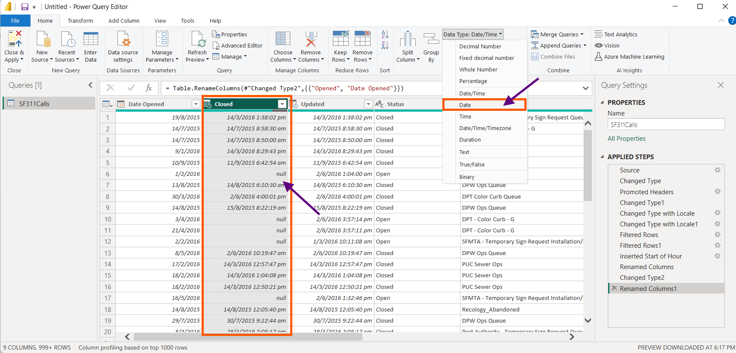  
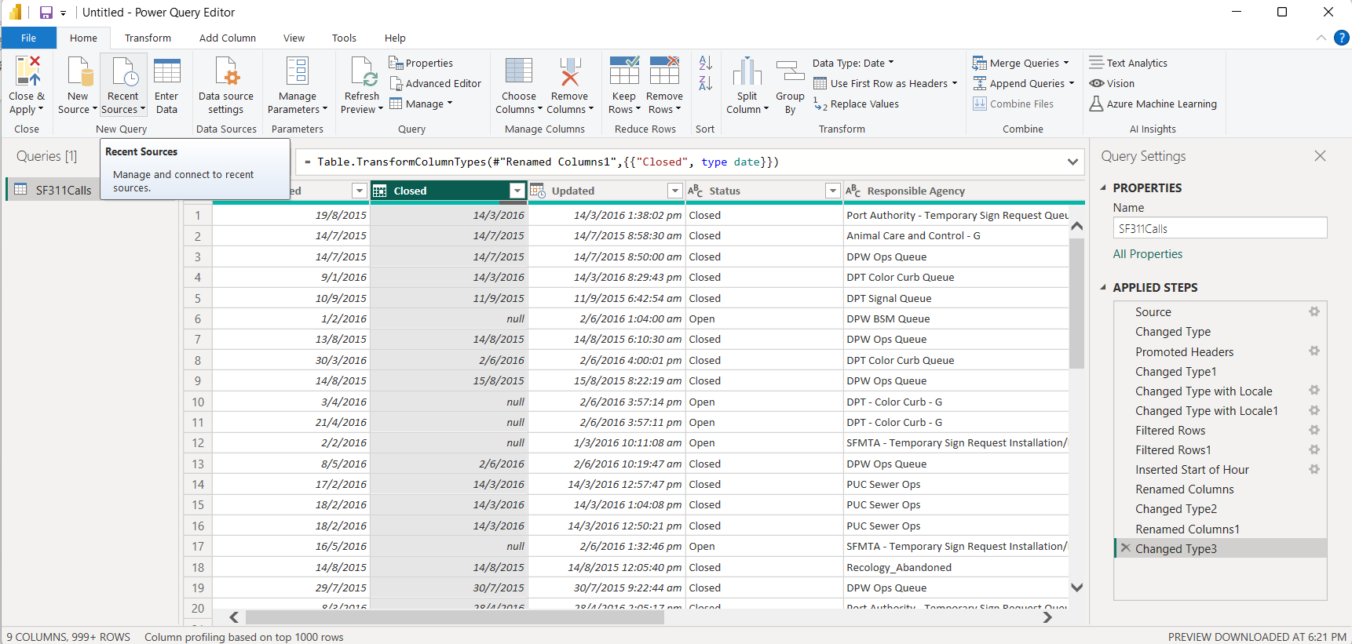

The table looks much better. Now, let’s navigate and import the table categories.

Select “Home”, select “New Source”, Choose “Text/csv”.

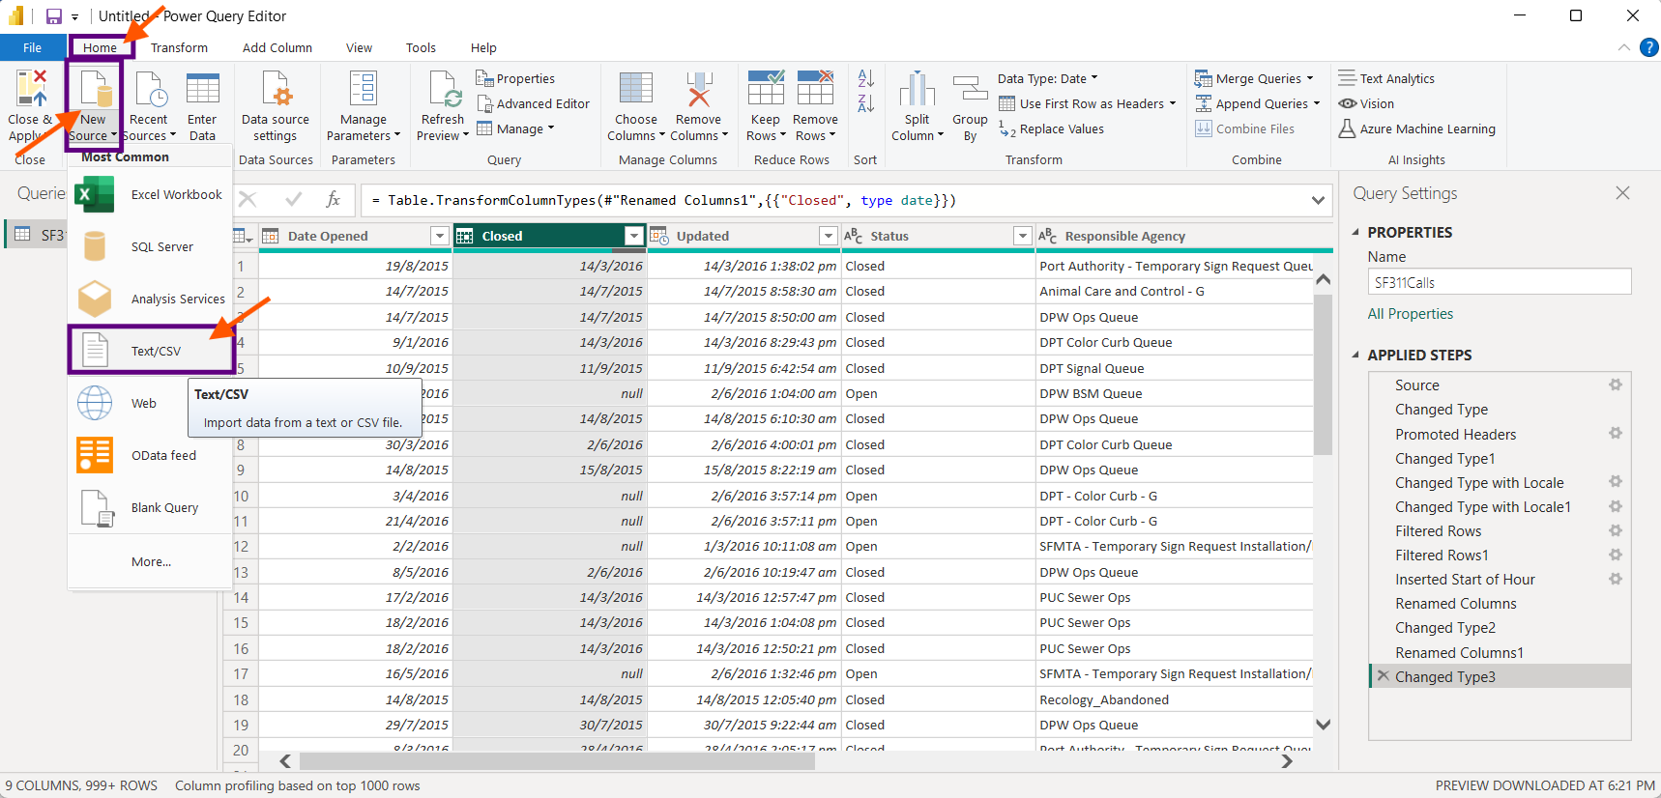

Navigate and import the “Categories” file from the PC. Press “Open”

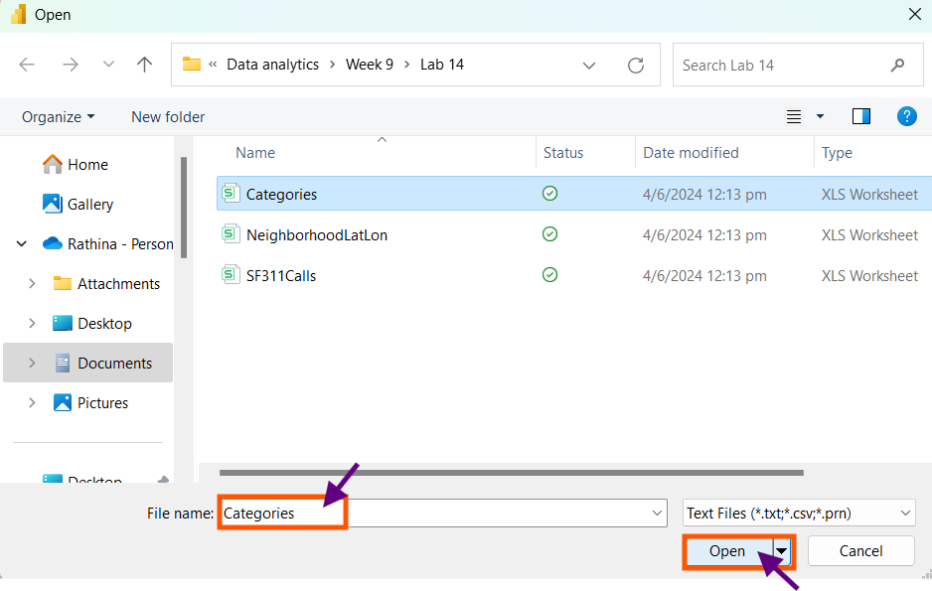

Press “OK”

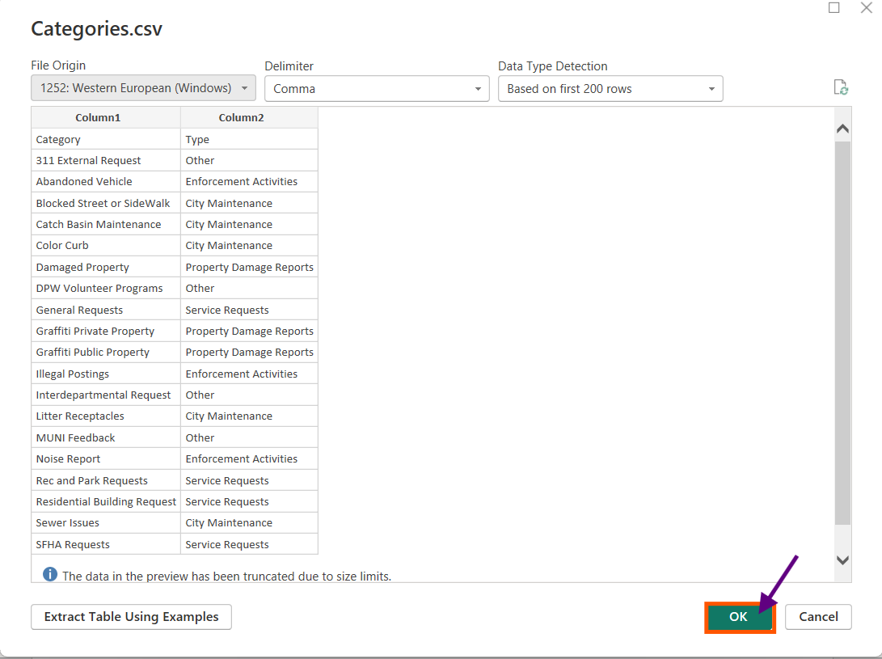

Select “Use First Row as Header”.

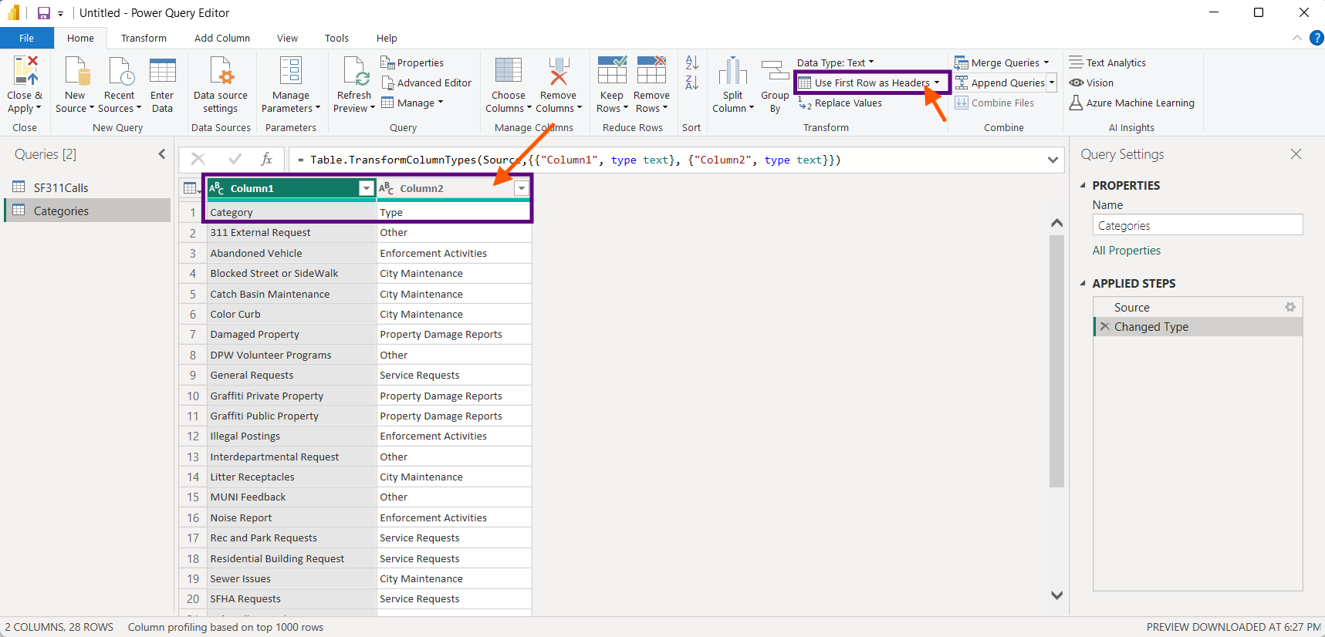

We find the data types has been changed. Click “SF311Calls” table.

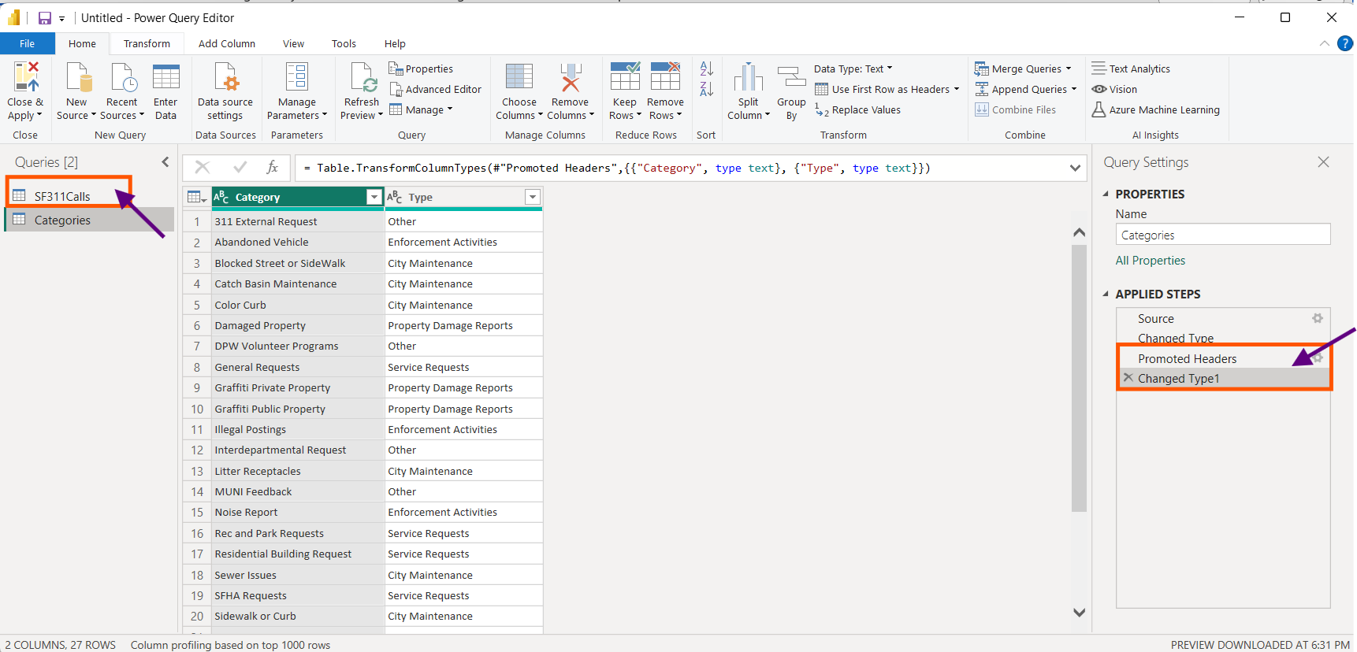

We find the table “SF311Calls” has a category column in it. Select “Merge Queries”, Choose “Merge Queries”.

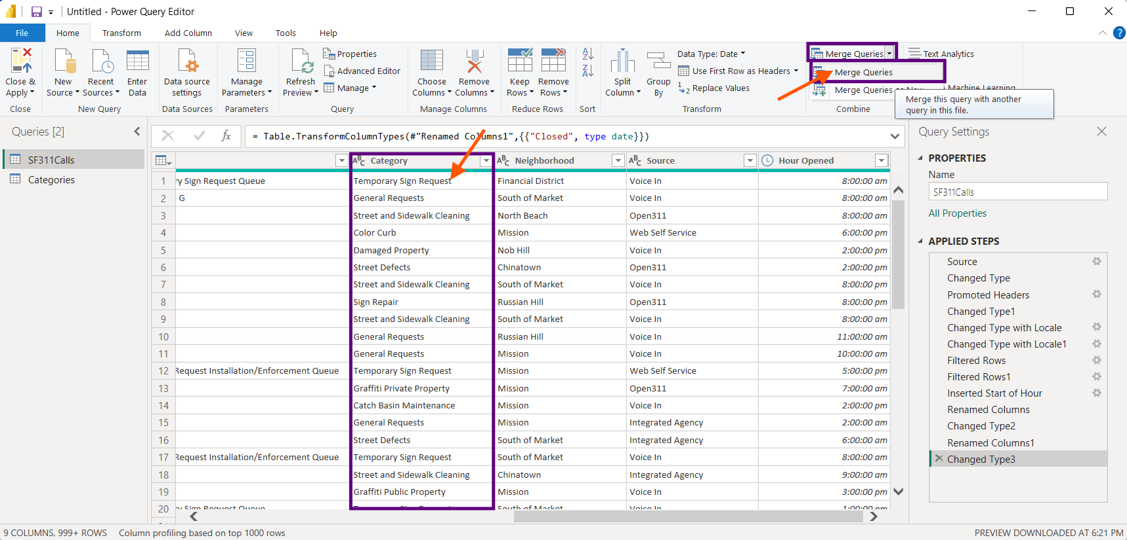

Merge the two tables using “Category” column. We find the selection matches 188846 rows from the first table. Press “OK”.

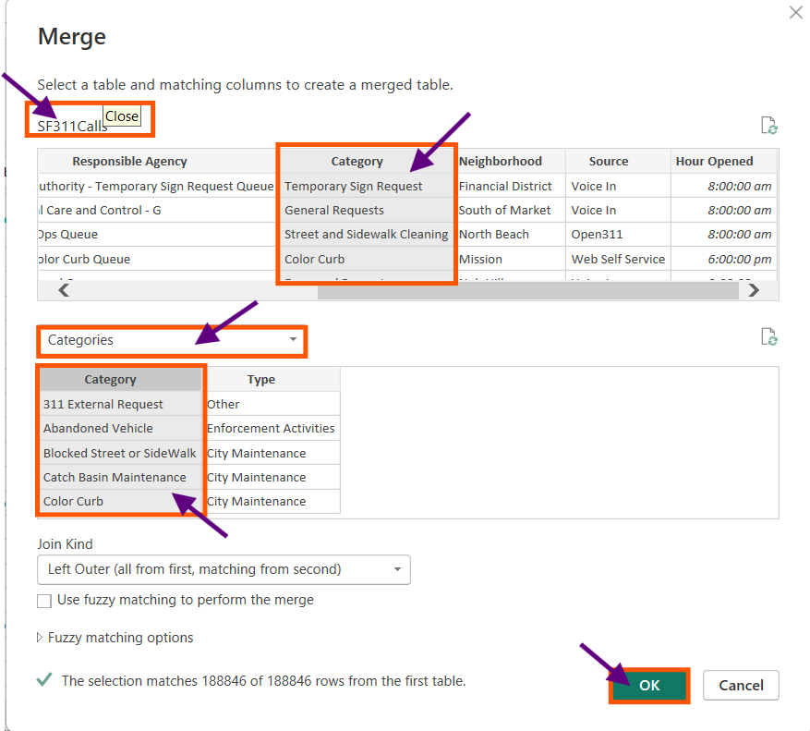

We find the last column to be added to the SF311Calss table under the name “Categories”. Select the drop-down button, Select “Types” column.

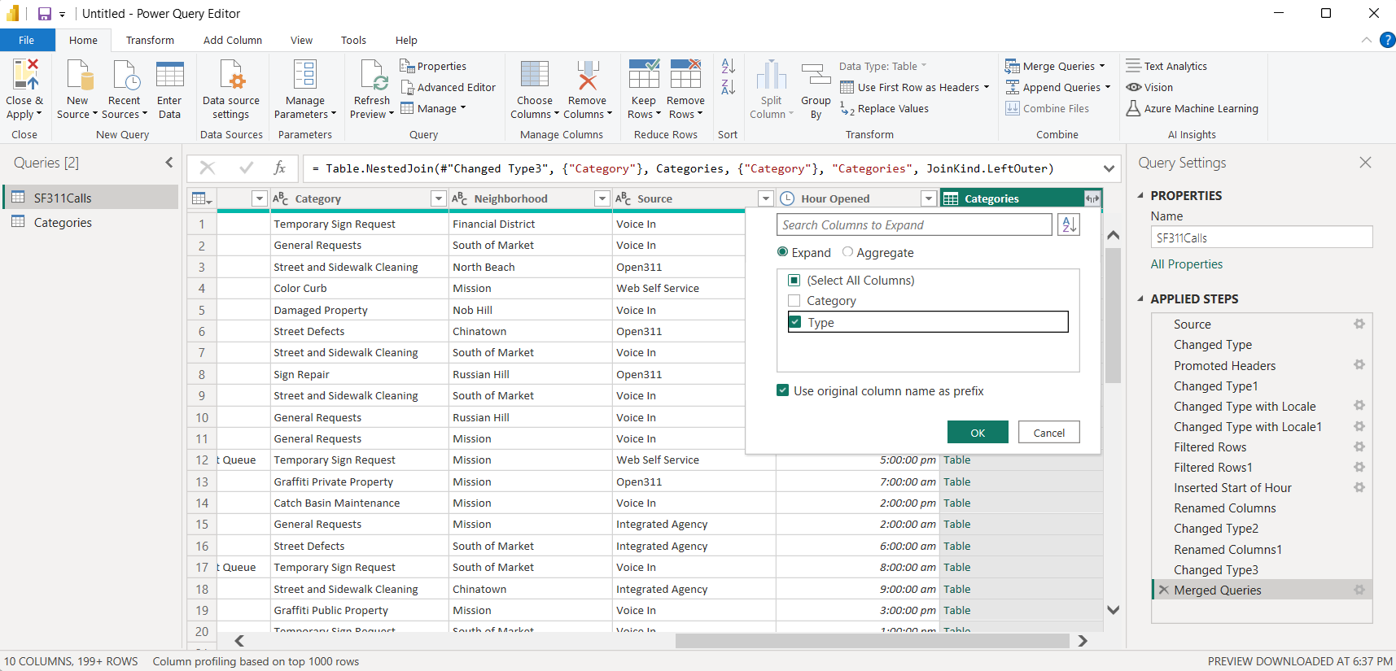

Now we find the new column loaded, Select categories table, right click it and disable the “Enable load”

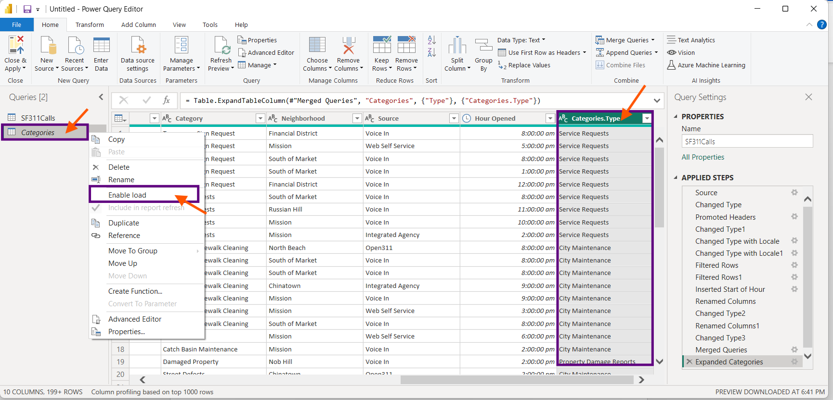

In the Home select the table “SF311Calls”, “Close and Apply”, Select “Close and Apply”.

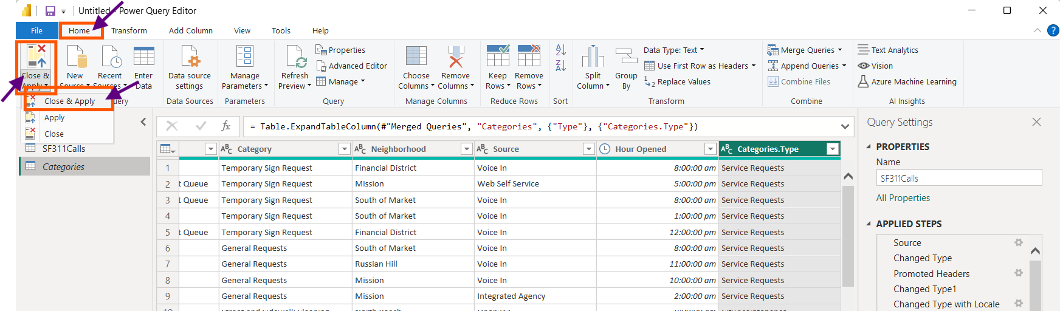

In the Power BI Desktop, we find the table SF311Calls alone loaded. Choose the Data button on the left side.

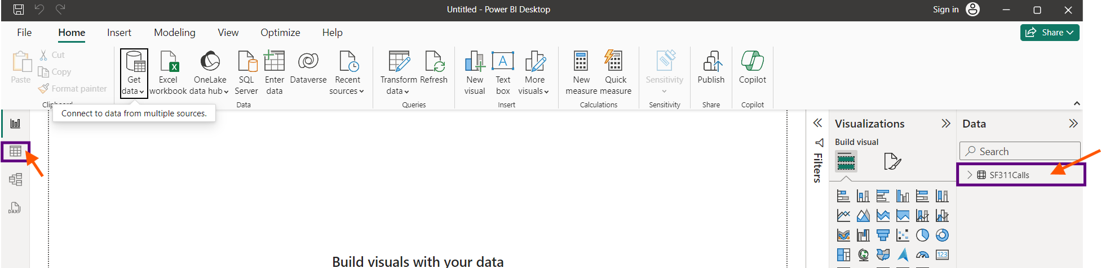

We find all the columns in SF311Calls table are loaded in the Power BI Desktop.

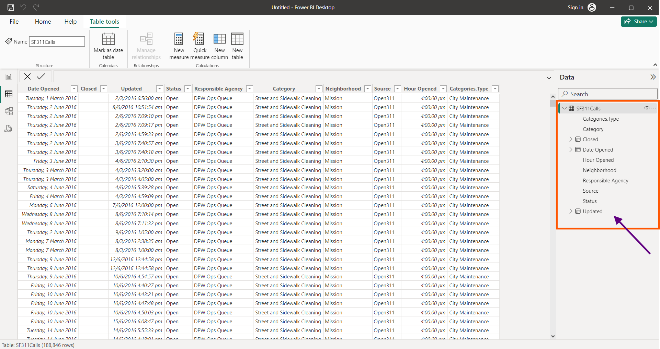

To view it in the Diagram view

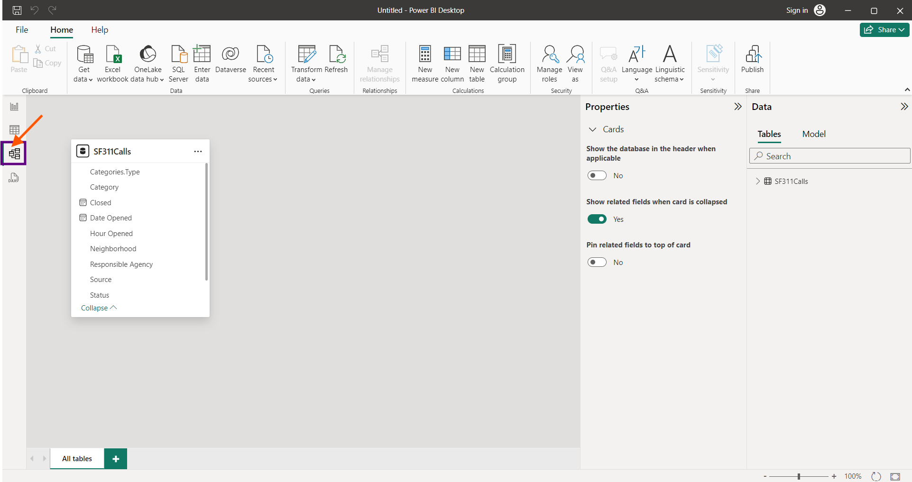

To Create a Date Table, Go home select “New Table” rename it as “Date”. Using DAX we create the date table with starting date and end date

Date = CALENDAR(DATE(2015,01,01),DATE(2016,09,31))

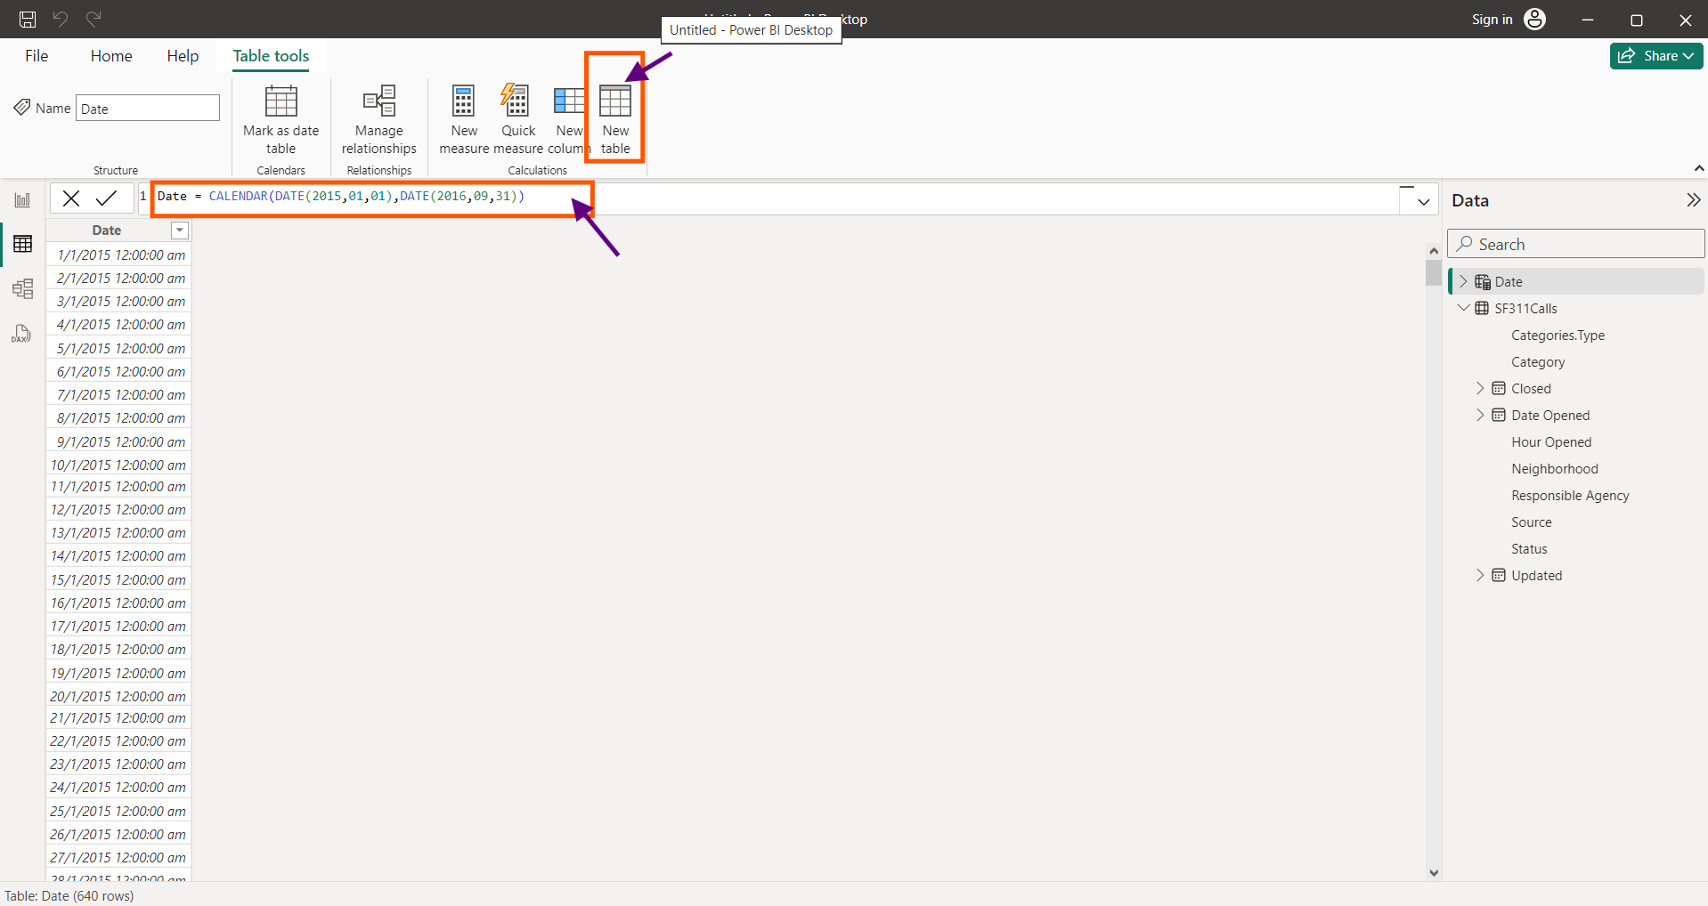

Select the Date Column, to Change the Format, Select “Format” and choose the desired style.

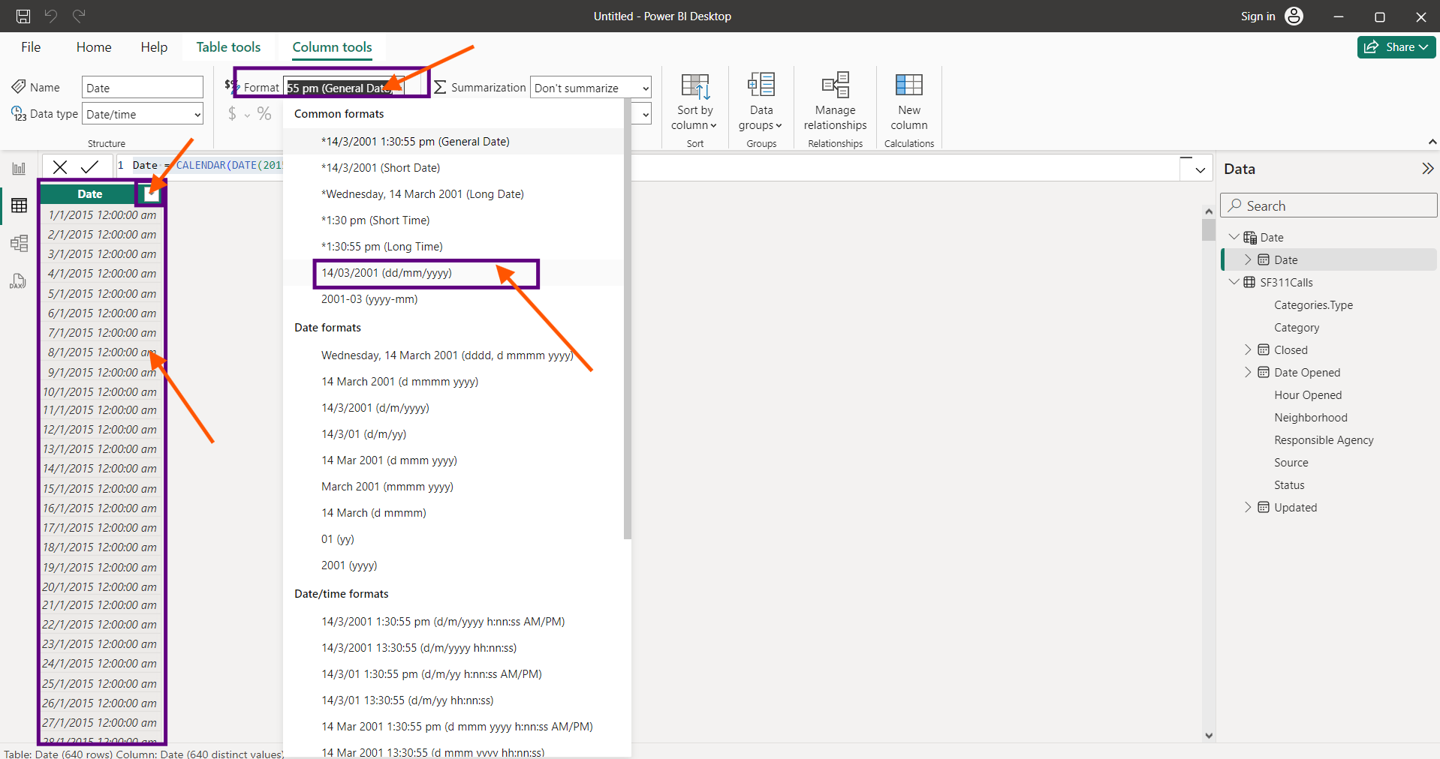

To have few more columns in the date table we add few new calculated columns as below.

To have a Year column, We create it as a calculated column by Select “New Column” and using the syntax

Year = [Date].[Year]

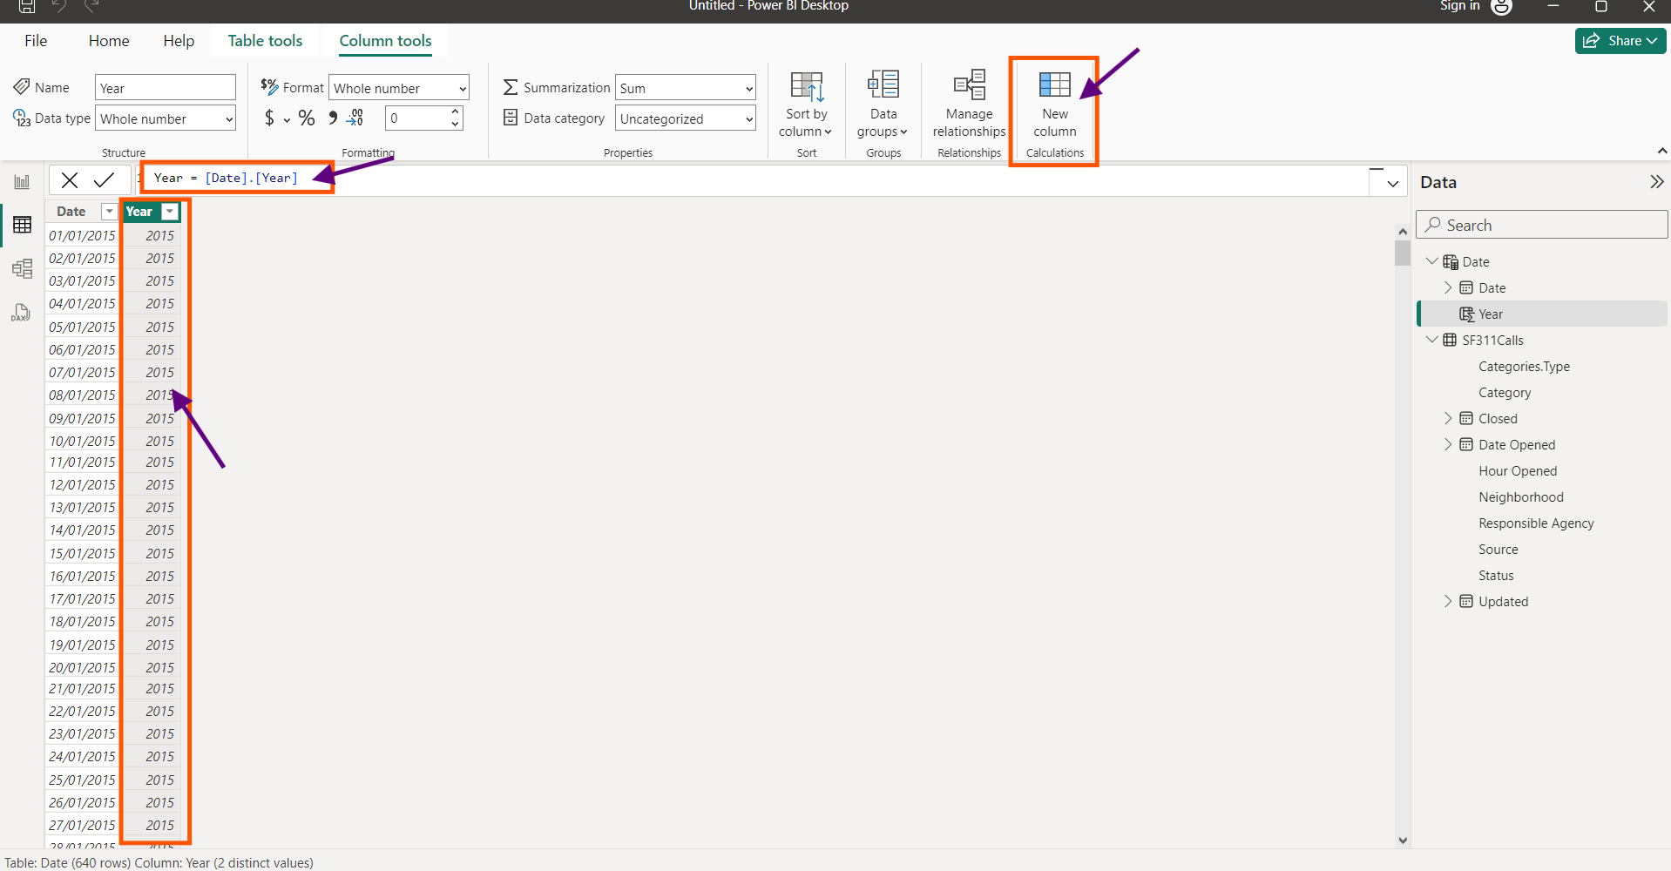

Similarly, Month column is created

Month = [Date].[Month]

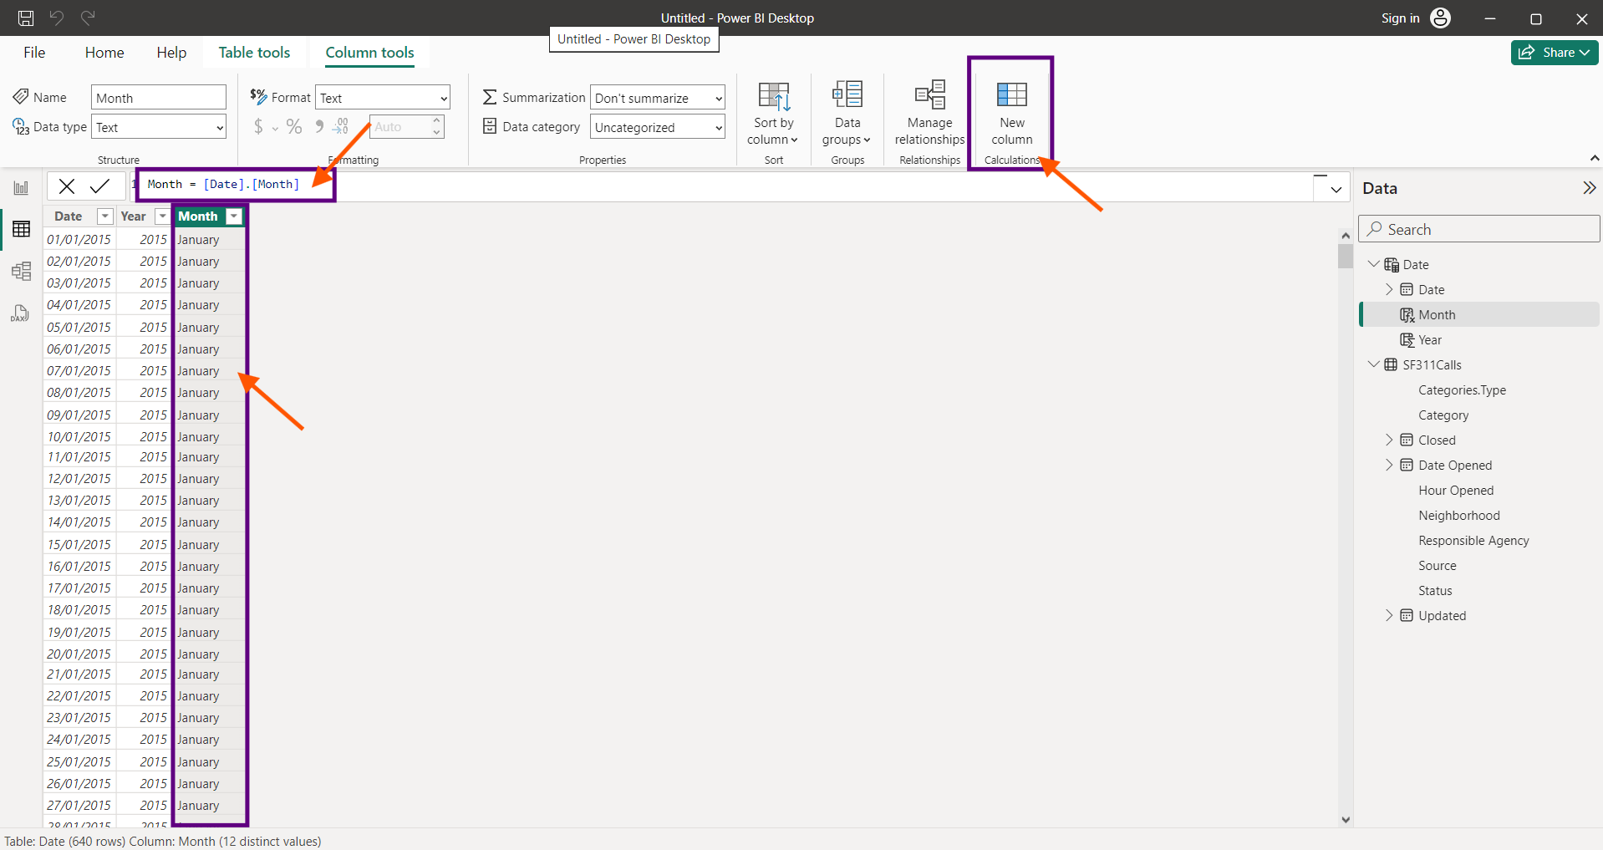

Month Number Column

Month No = [Date].[MonthNo]

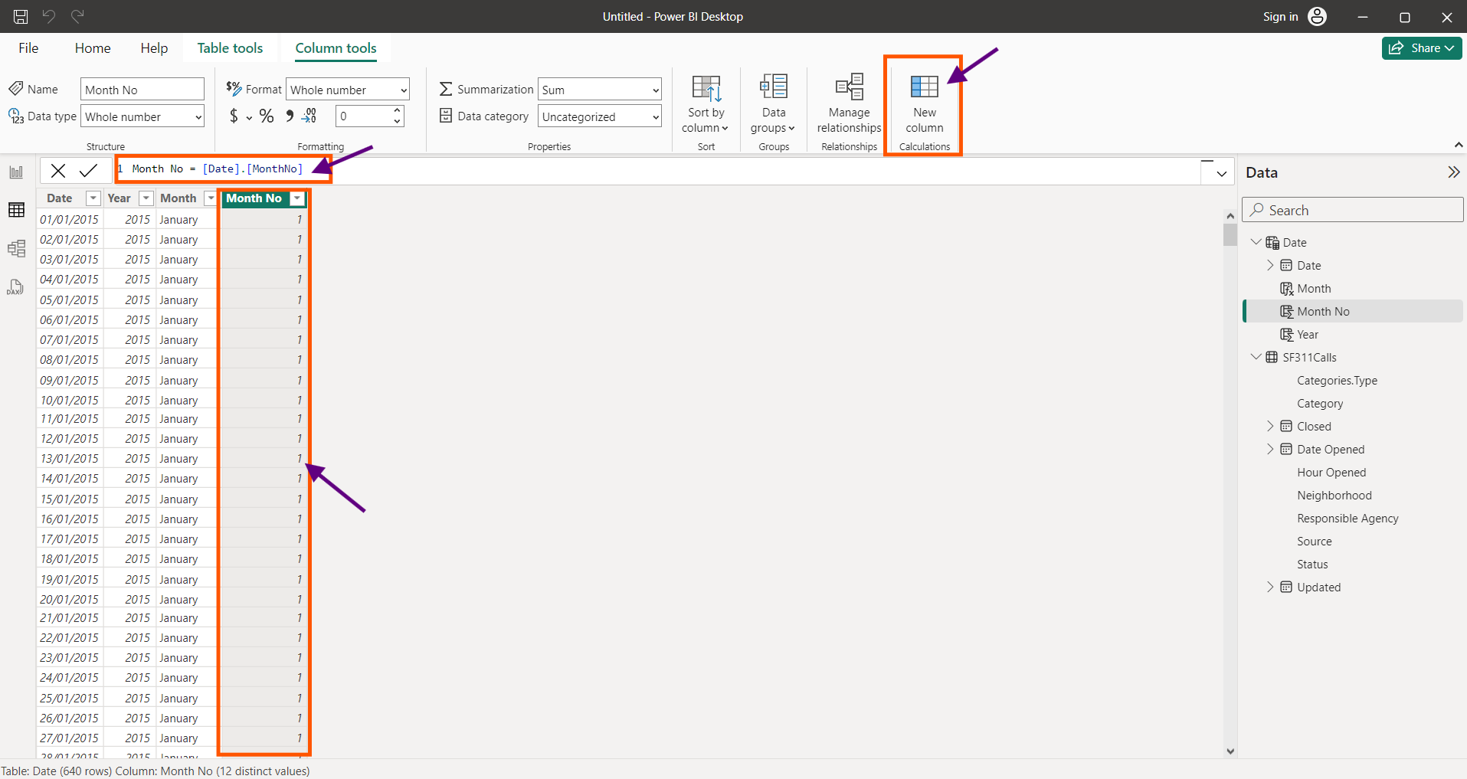

Day Column

Day = FORMAT([Date],"ddd")

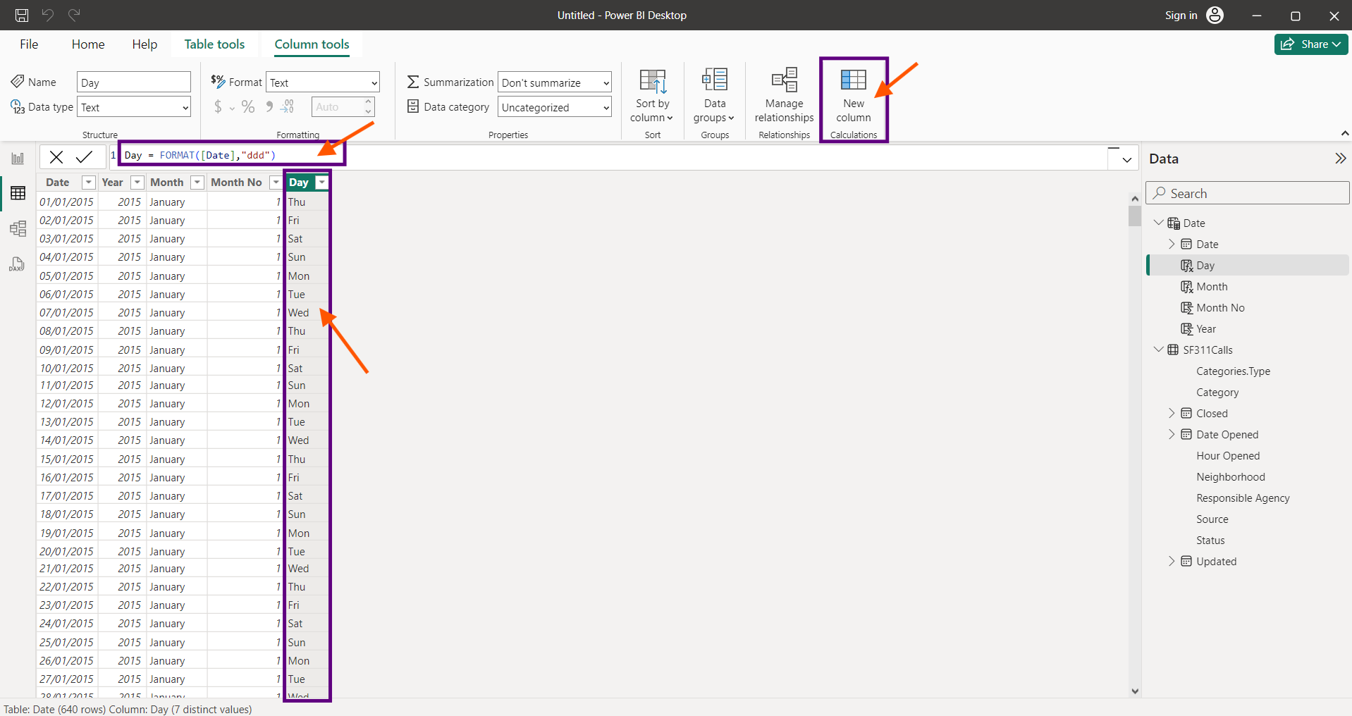

To sort the months column

Select “Month” Column, Select “Sort By”, Select “Month No”.

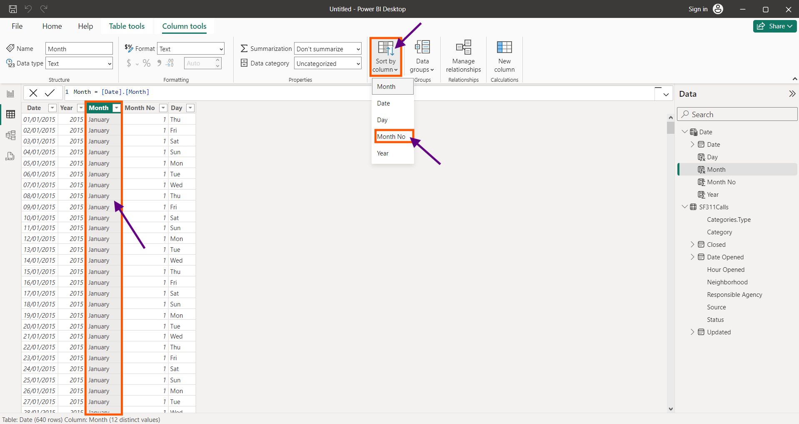

Now Choose “Month No” column, Right click and select “Hide in report view”.

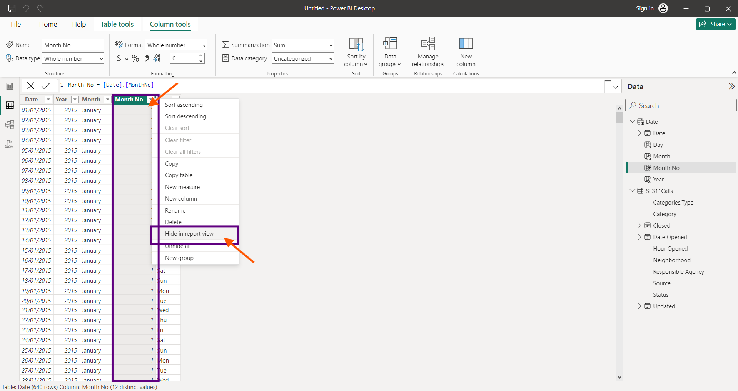

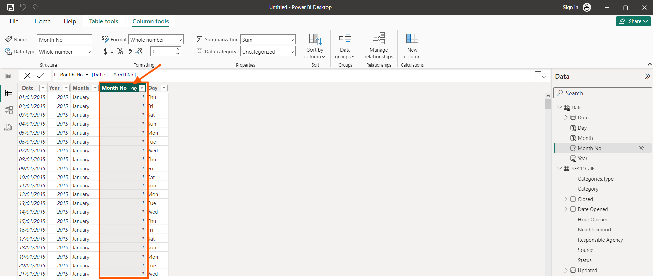

To create relationship select “Manage Relationship”

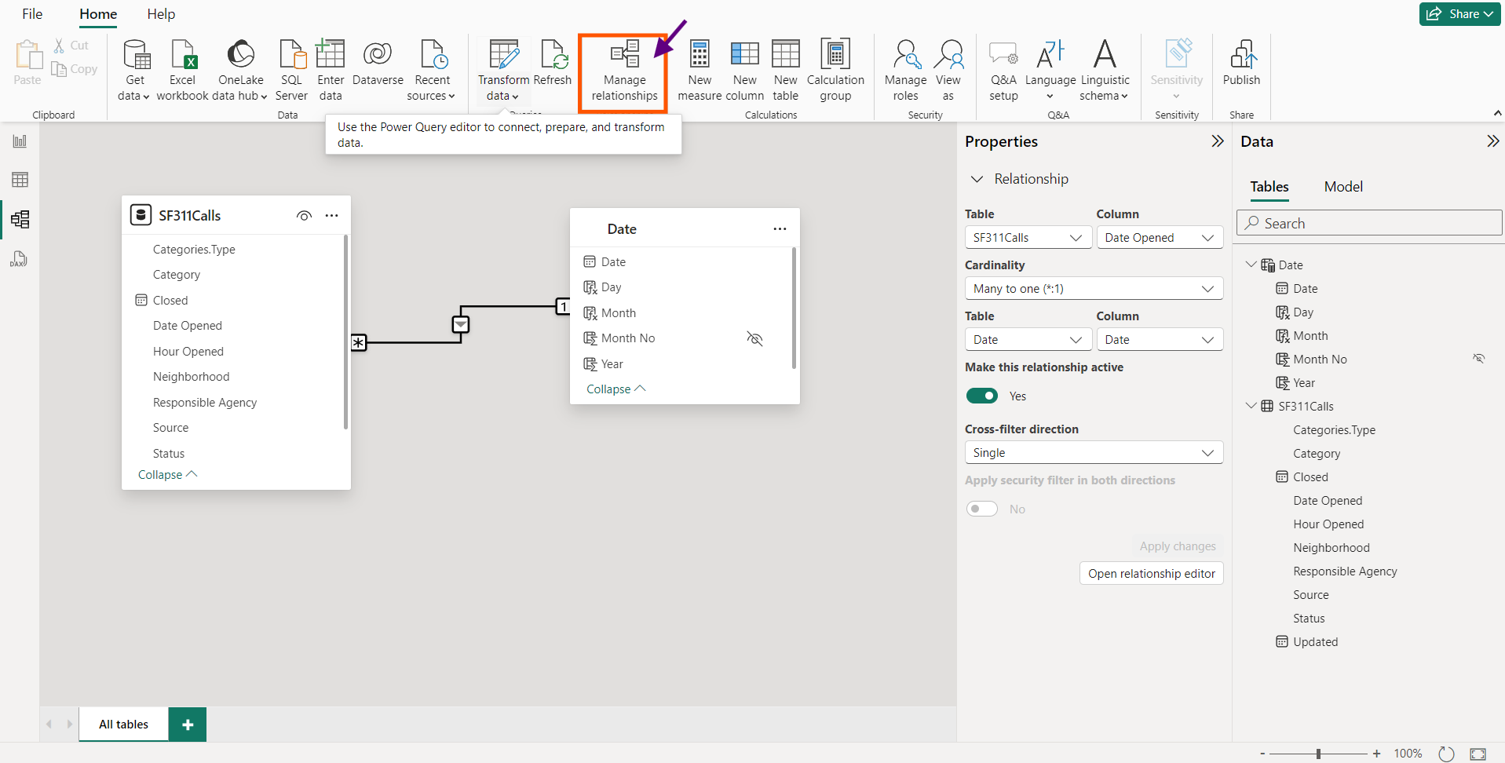

Click “New Relationship”

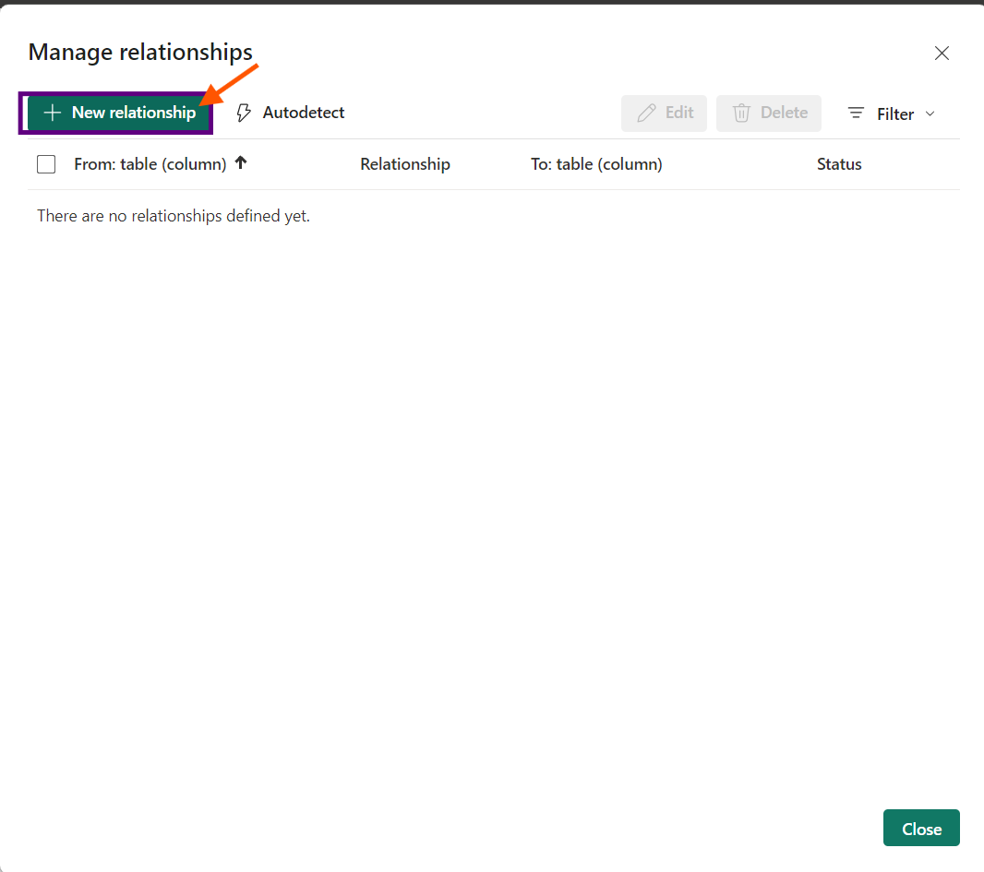

Select “SF311Calls” in from table, select “Date” in To table, Choose “Date Opened” from “SF311Calls” table and “Date” from “Date”. We can find “Make this relationship active” to be marked. Press “Save”

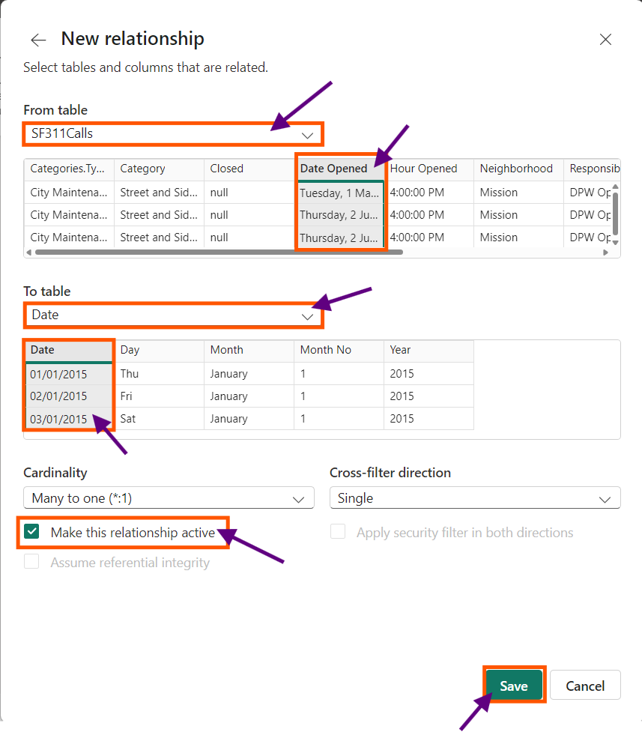

We find the two tables are connected properly.

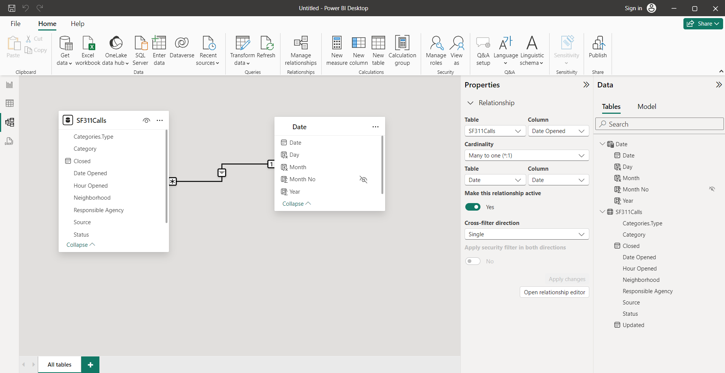

We find that some closed date is not available since it is a data 6 years back. We like to conduct some analysis by choosing the last date of the project from Date table (31/09/2016) as the last date.

Go Back to Data View. Choose “SF311Calls” table. Select “Date Opened”, Choose “Sort ascending”.

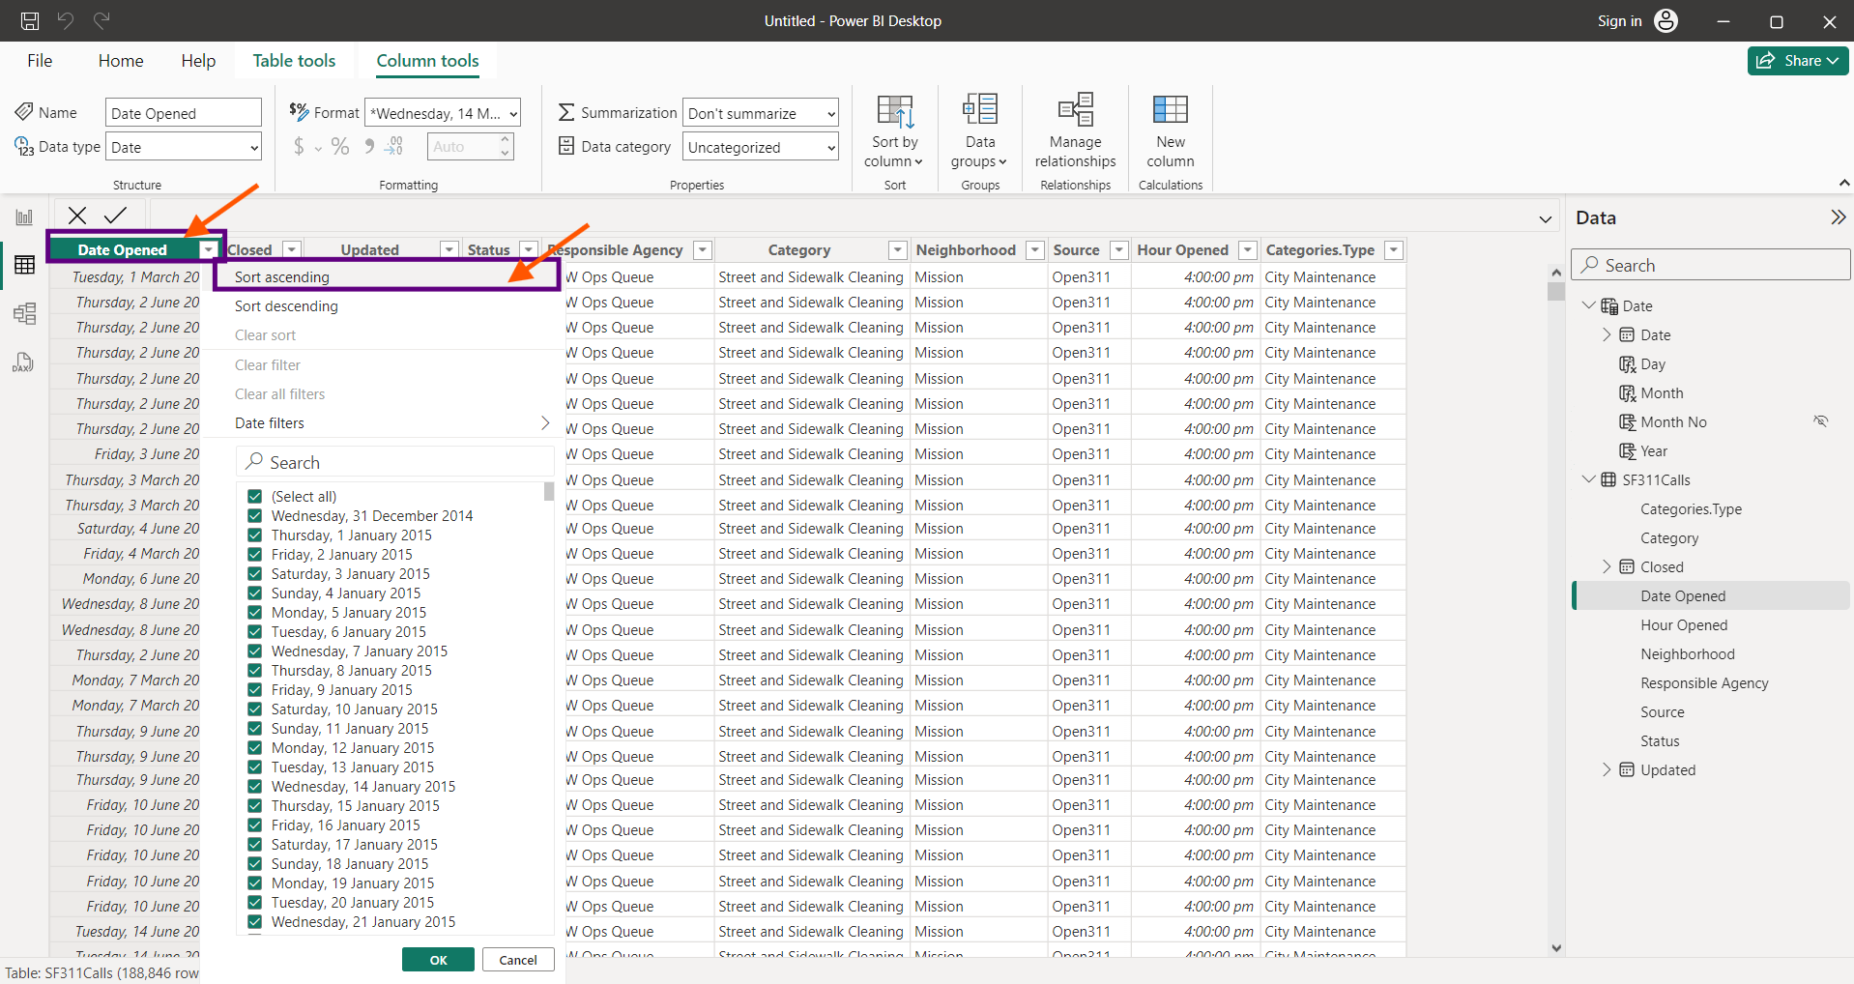

The Difference in Days is calculated using the DAX function DATEDIFFER and the calculated column is renamed as “Days Open”

Days Open = DATEDIFF([Date Opened],[Closed],DAY)

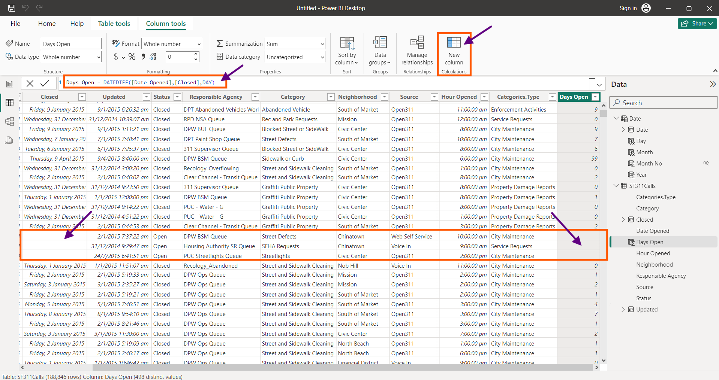

In the above Screenshot we find some of the values are missing in the calculated column where values in “Closed” column are missing. To make it proper, we use IF(ISBLANK()) to generate proper values.

Days Open = DATEDIFF([Date Opened],IF(ISBLANK([Closed]),MAX('Date'[Date]),[Closed]),DAY)

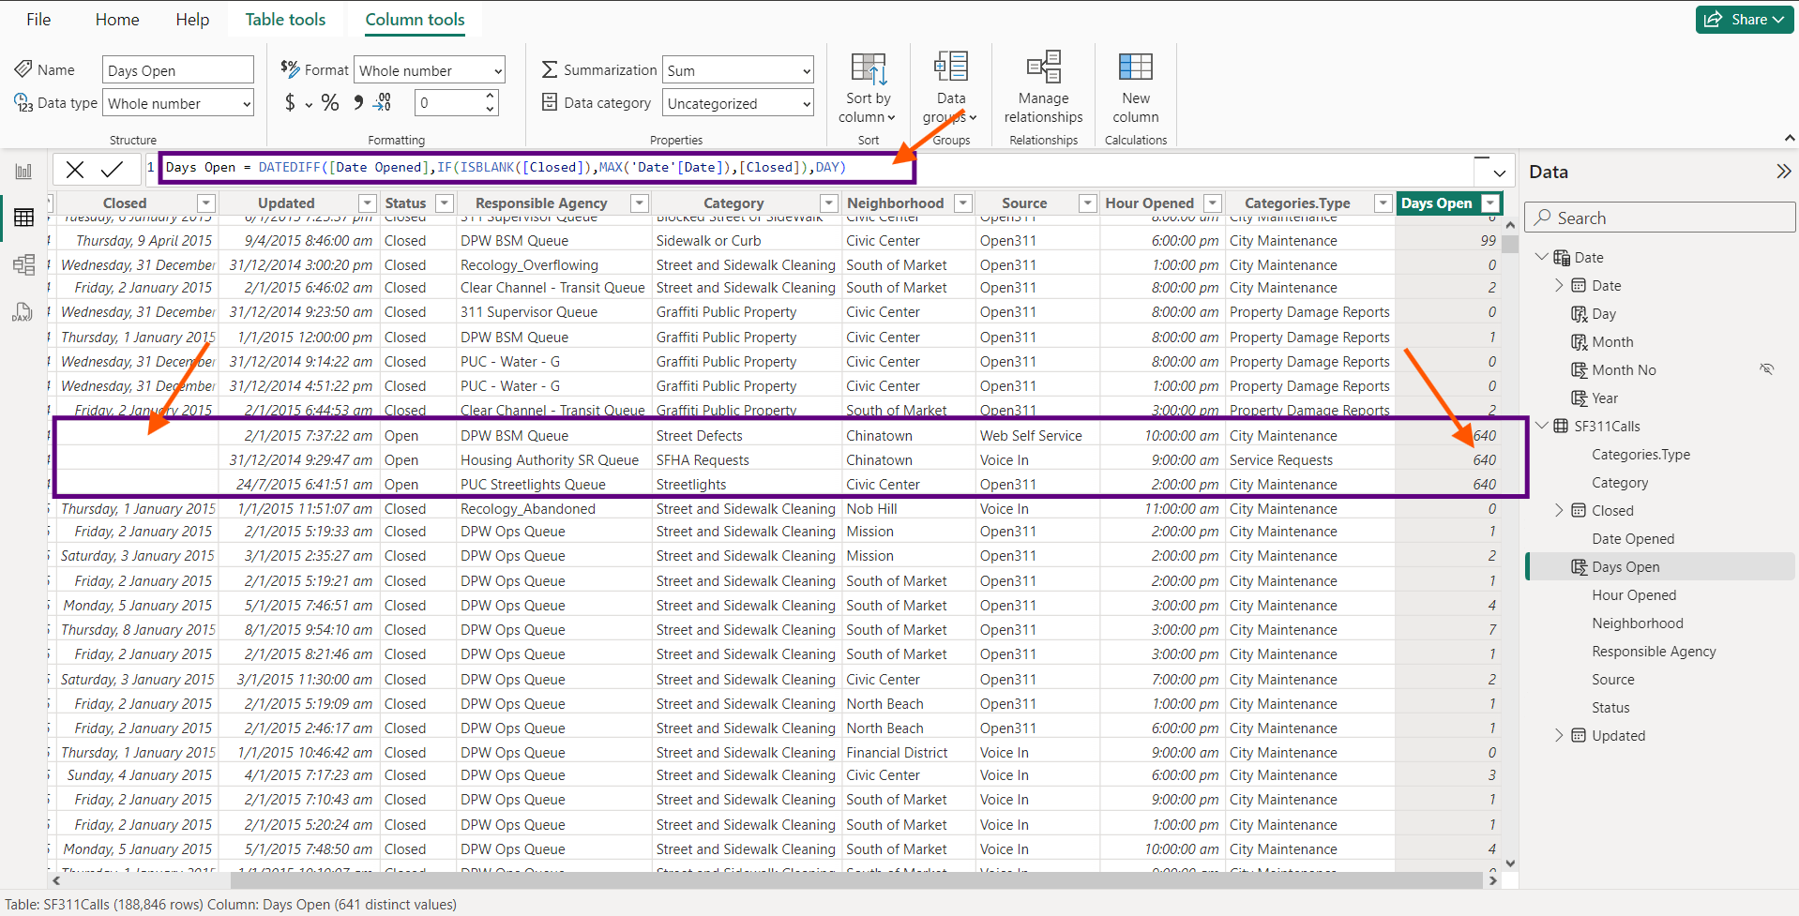

To do the calculated measure “Number of Cases” Select “Home”, select “New Measure”,

Number of Cases = COUNTROWS('SF311Calls')

The COUNTROWS counts the number of rows in the table.

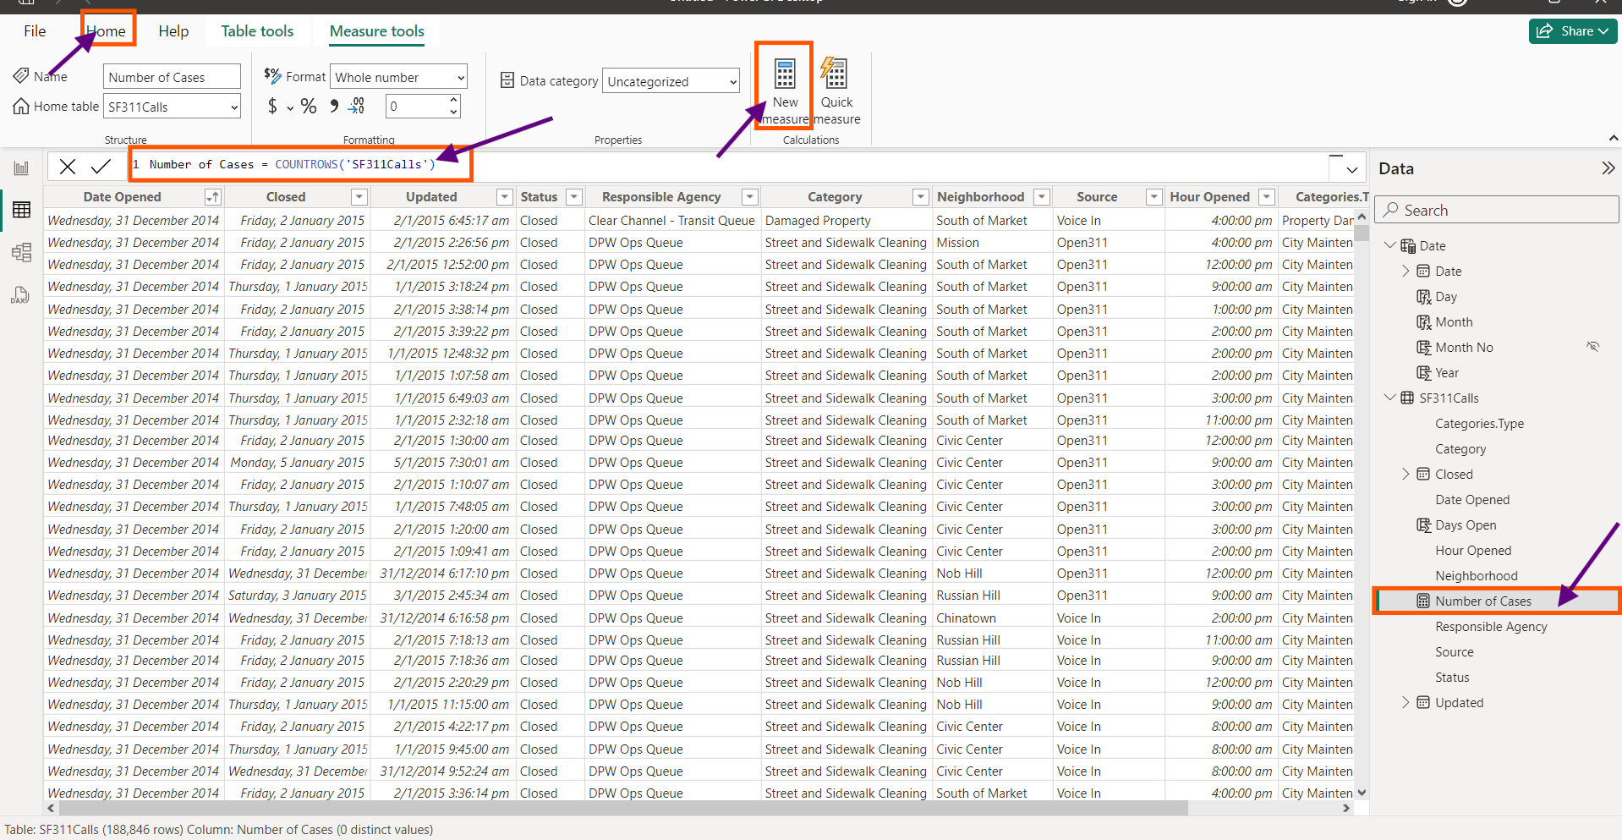

To Calculate the Previous months number of cases

Previous Month Number of Cases = CALCULATE([Number of Cases],PARALLELPERIOD('Date'[Date], -1,MONTH))

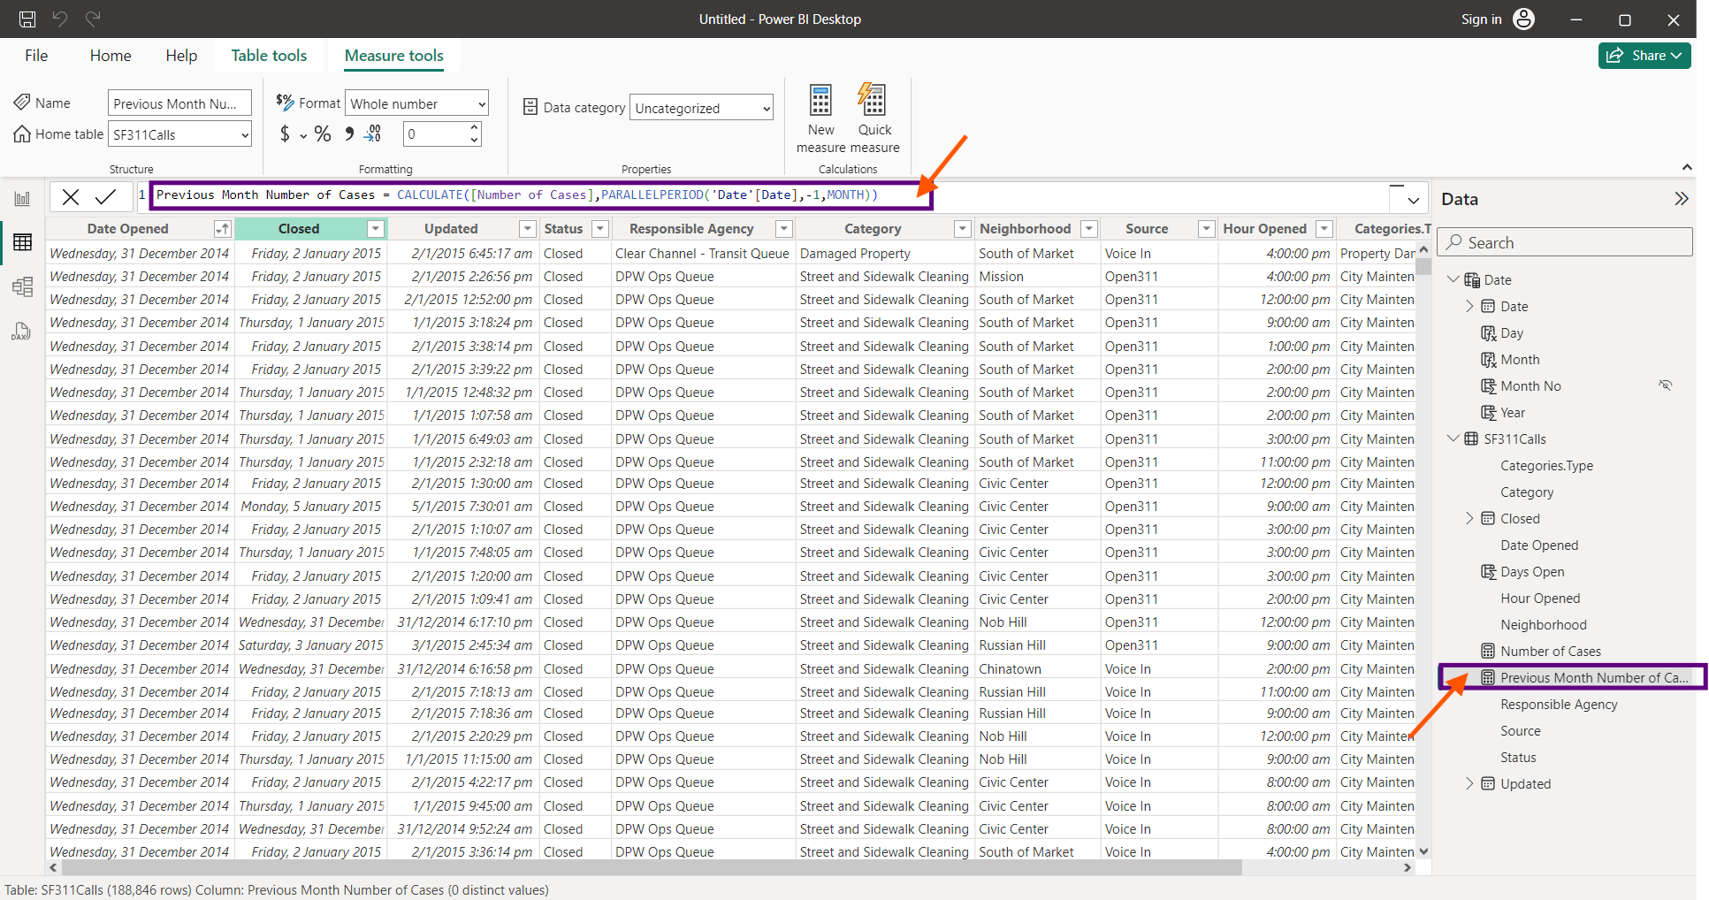

# LAB 15 Documentation

Navigate the file Lab15 in the PC. Double click and open it in Power BI

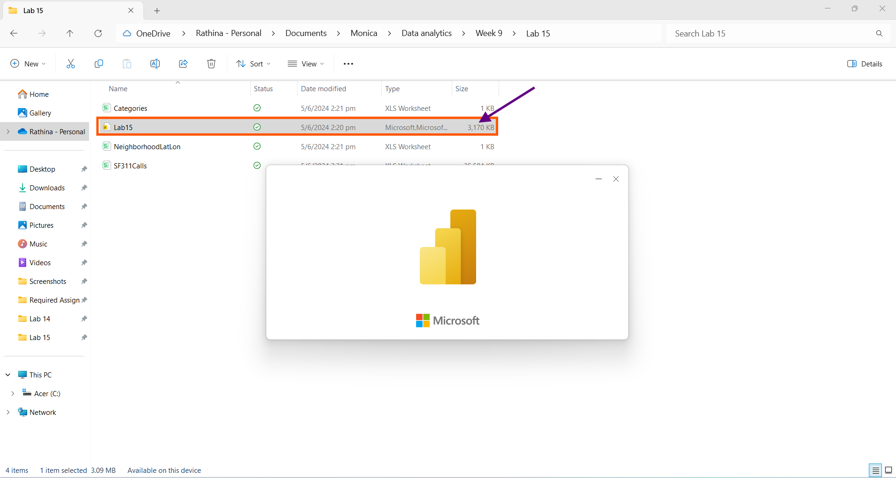

In the Data View we find all the necessary tables loaded.

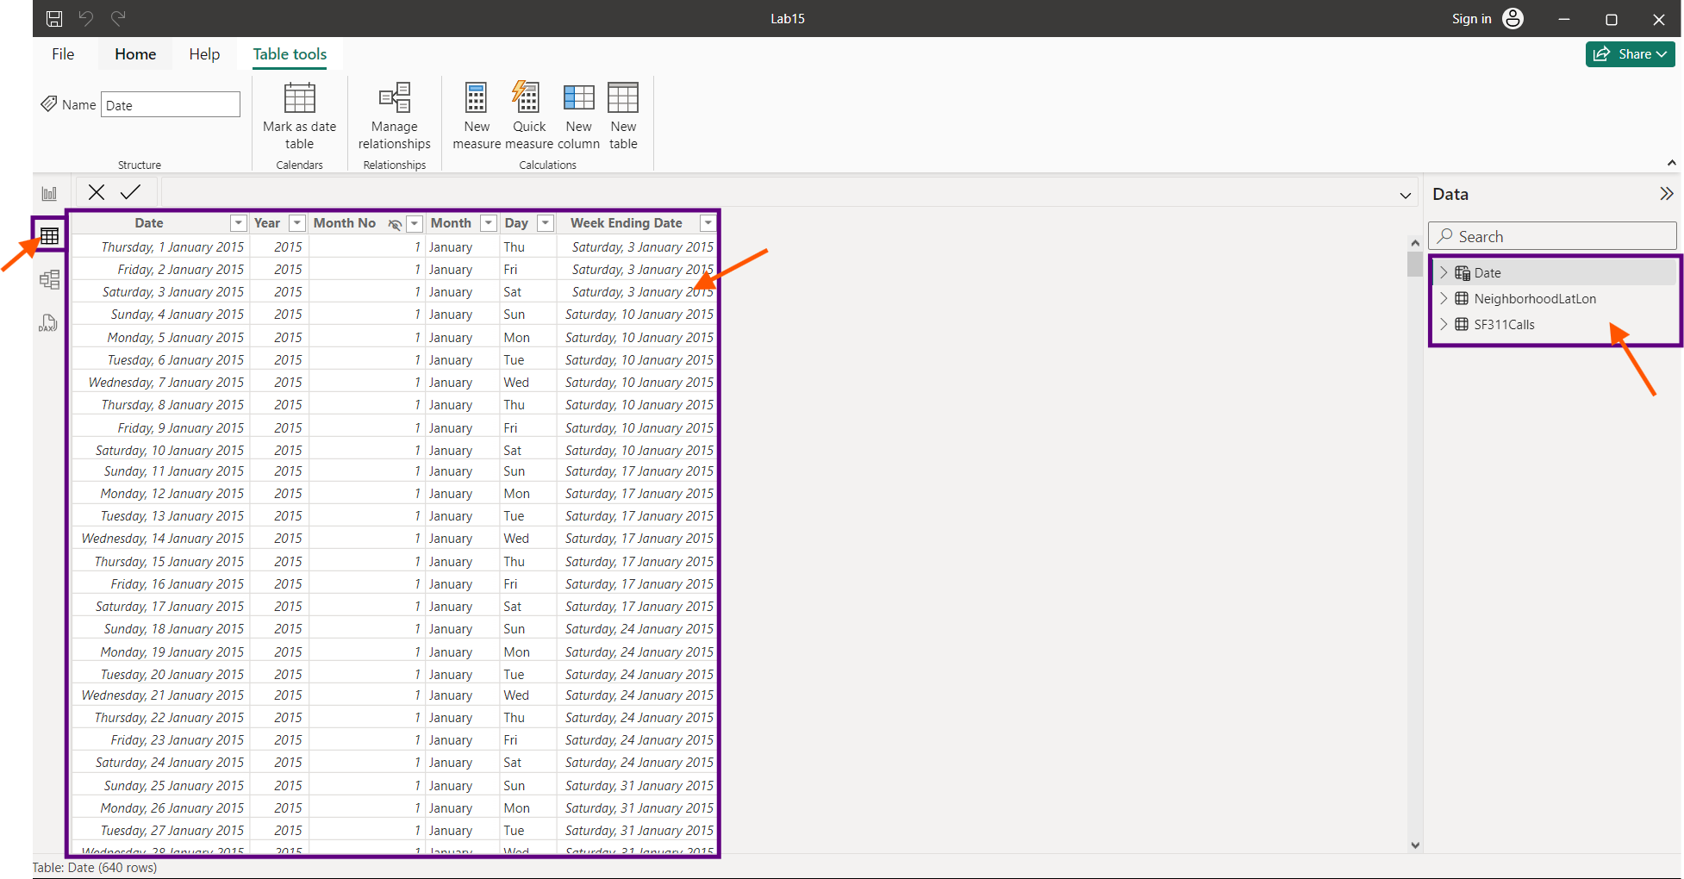

In the Diagram View, we find all the tables are having relationship between each other.

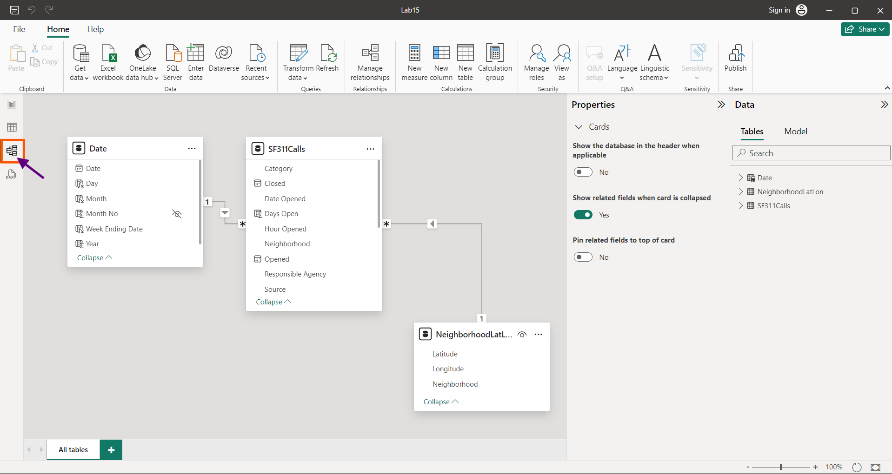

In the Report view, Select the “Table” button.

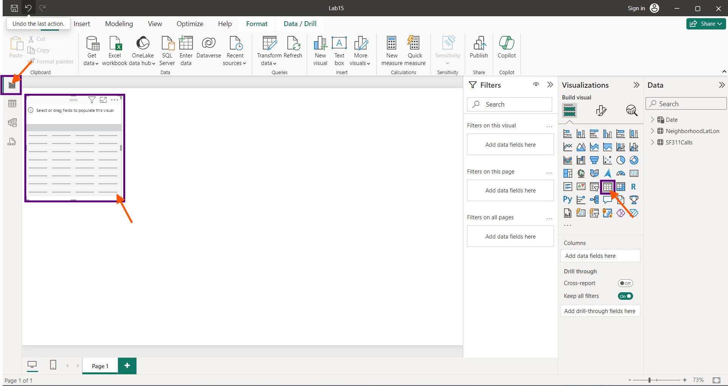

Click “SF311Calls” dropdown, Drag and drop necessary measures to “Add data fields here”.

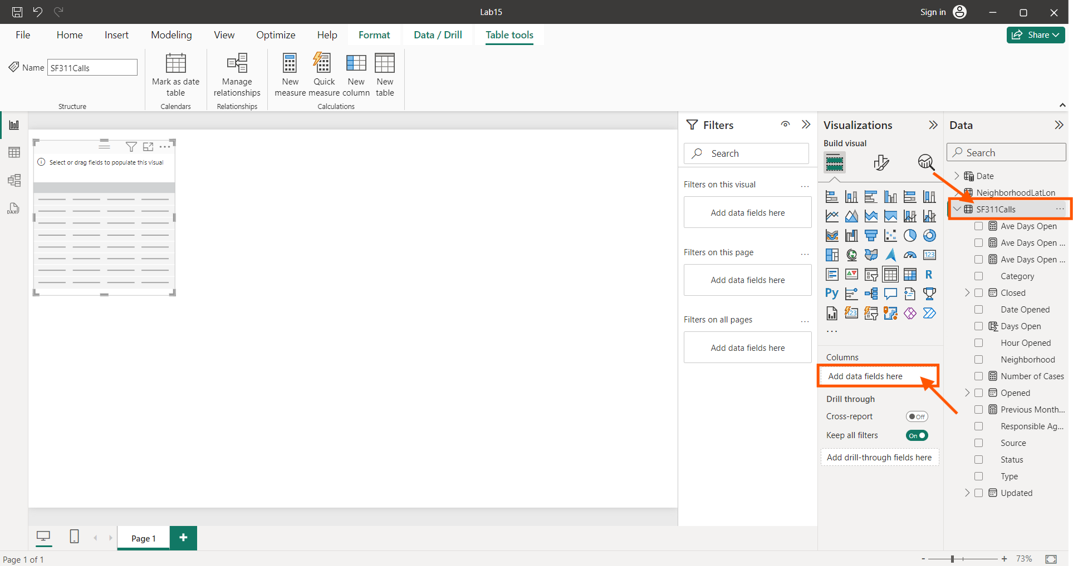

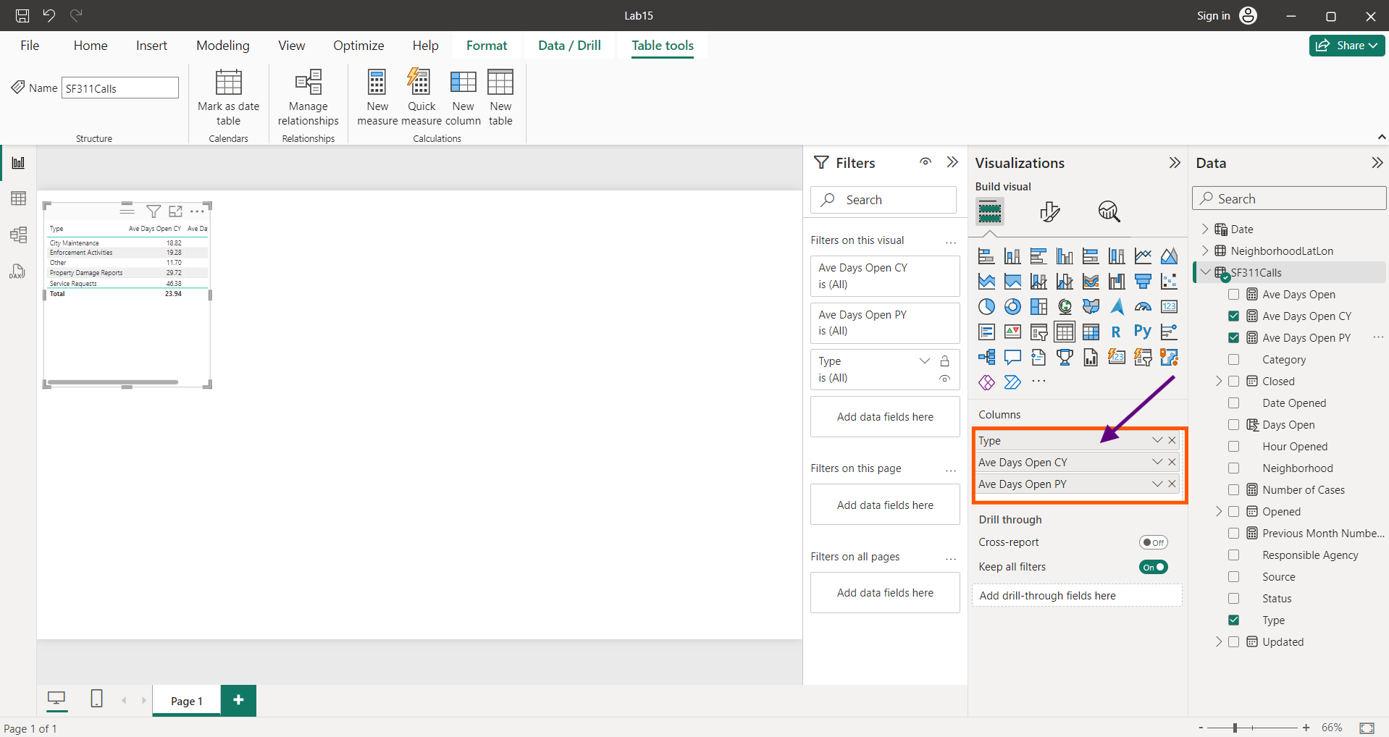

Stretch and enlarge the table, Click “Format” button , Select “Values” , increase the font size to “15”.

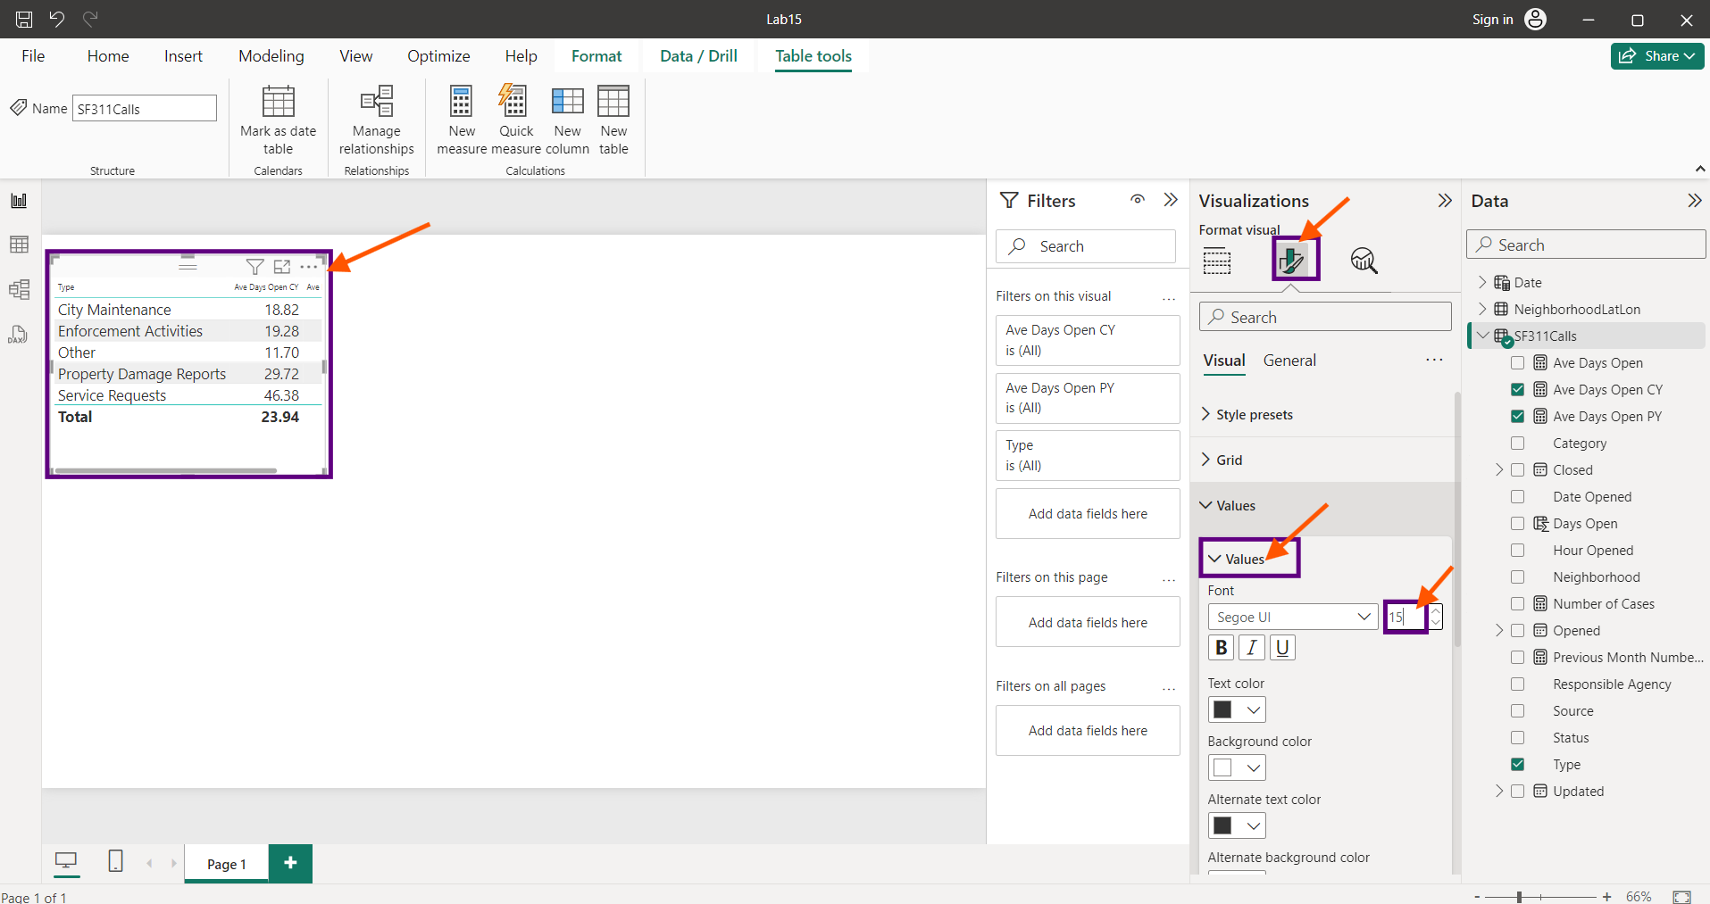

Table style can be changed using “style presets” , “Alternating Rows”.

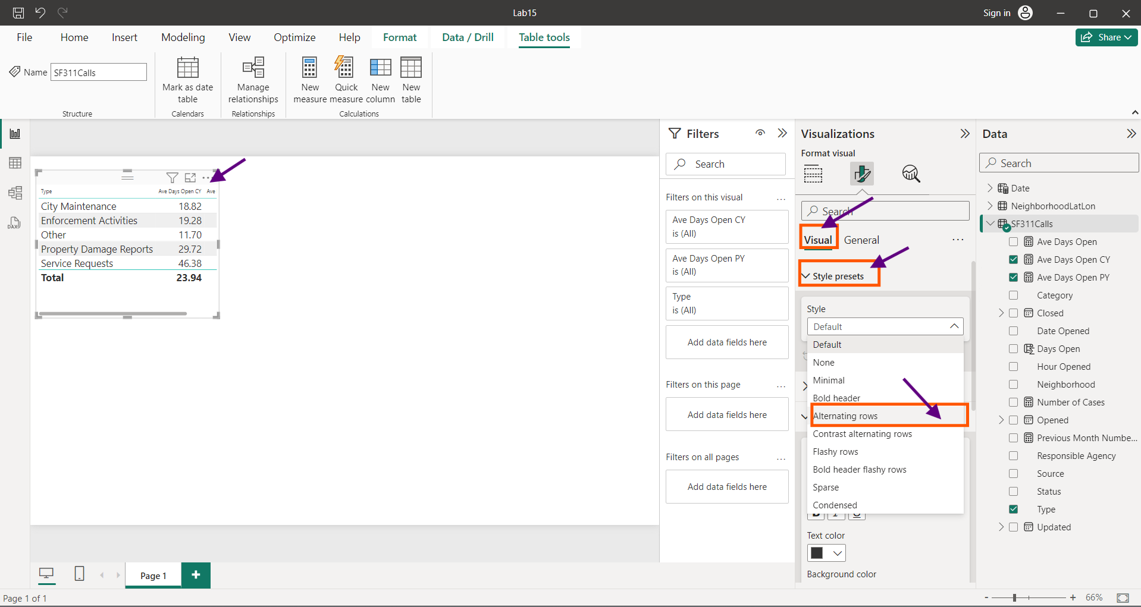

Change the “Column Header” Font size to “15”.

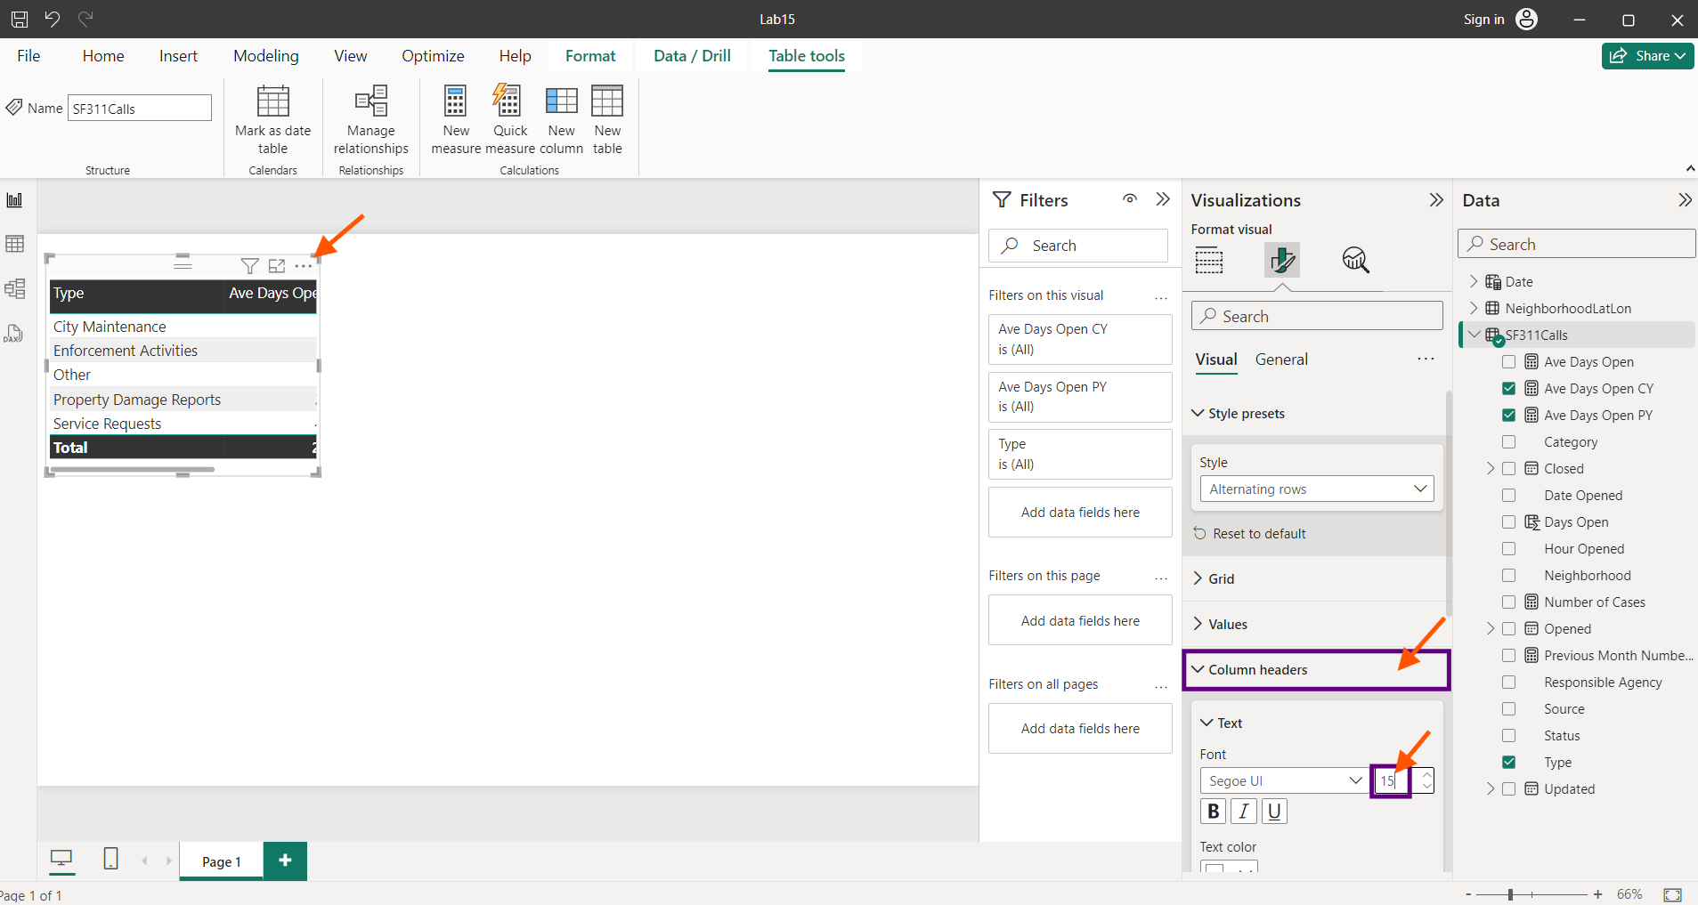

Now Enlarge the Table and make it appear clearer.

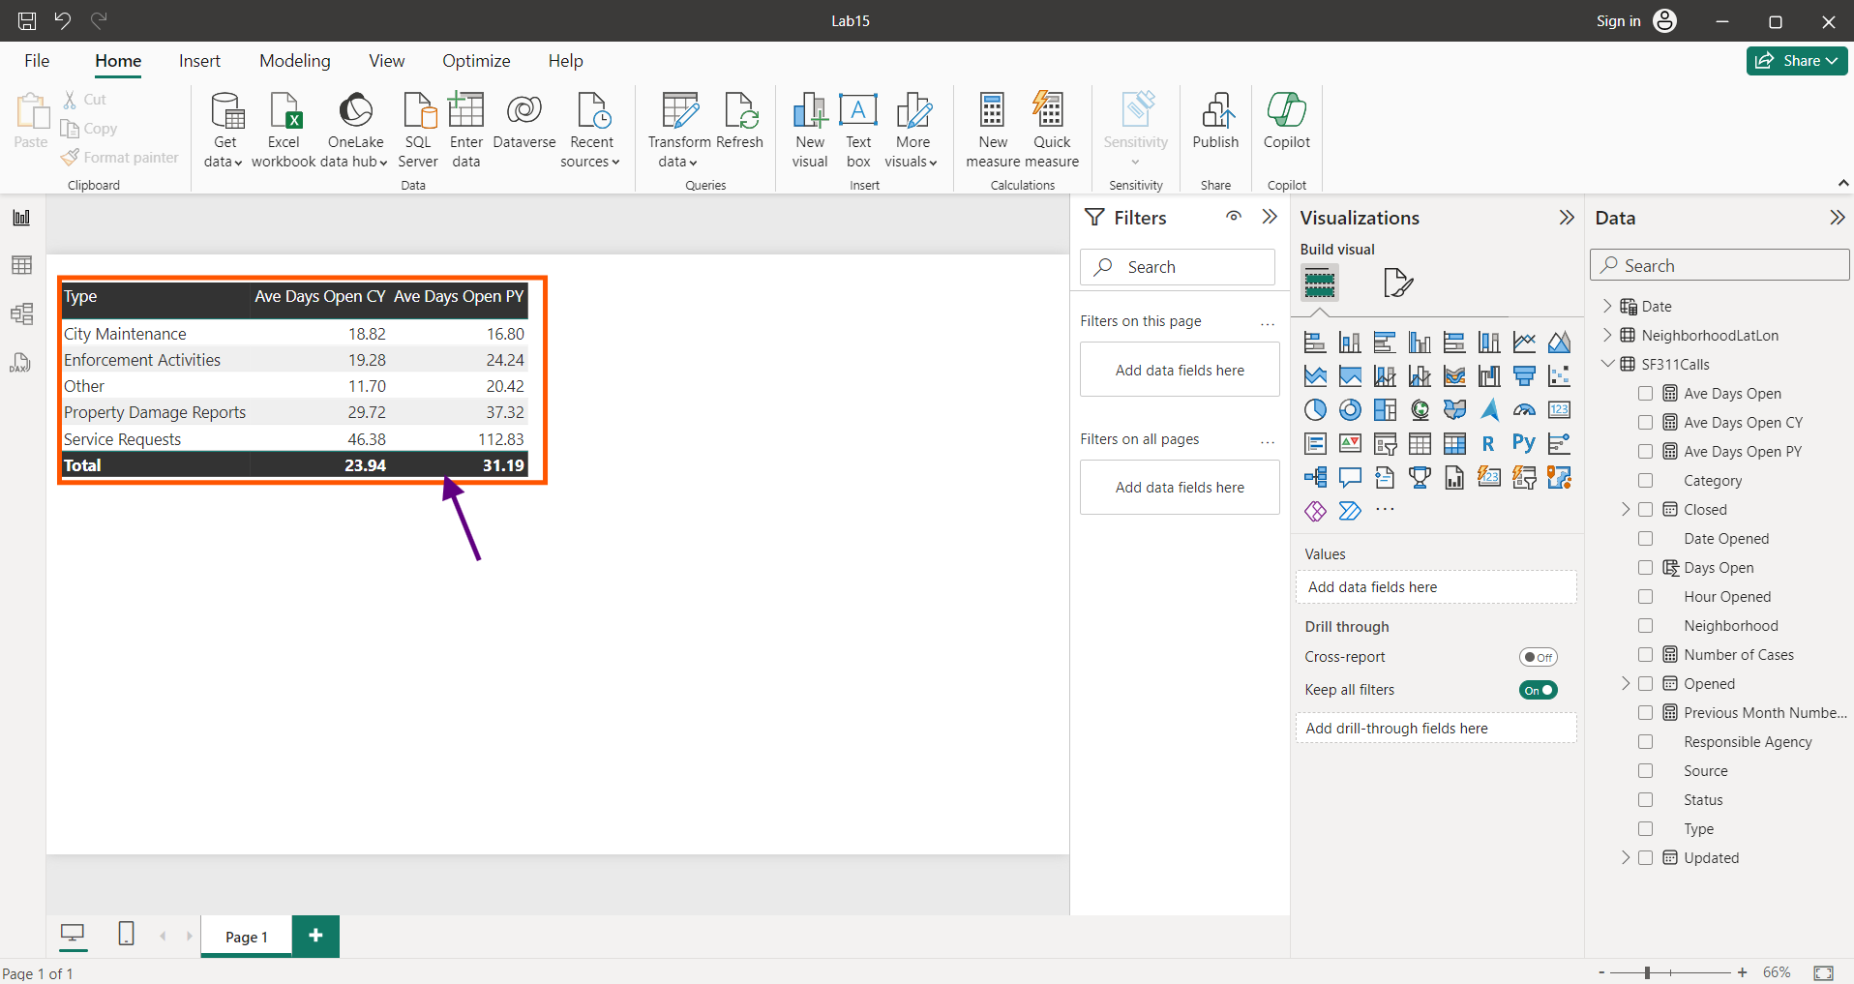

Thus, the table summarizes the average number of days that cases remain opened under different categories.

To create a new visualisation, click on the empty area in the canvas. Click 100% Stacked bar icon.

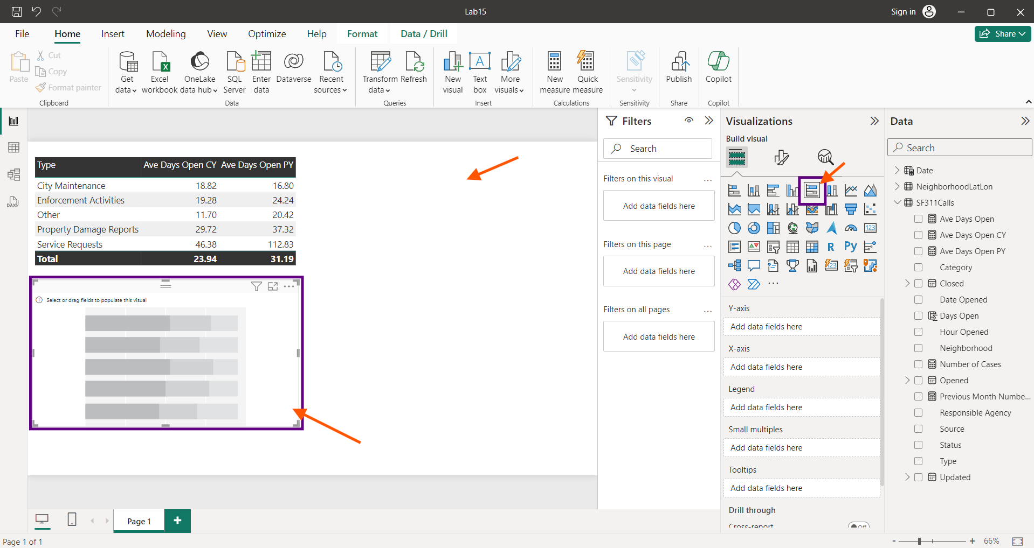

Create a 100% stacked bar by choosing “Type” along Y-axis, “Number of cases” along “X-axis” and “Year” from “Date” table along “Legend”.

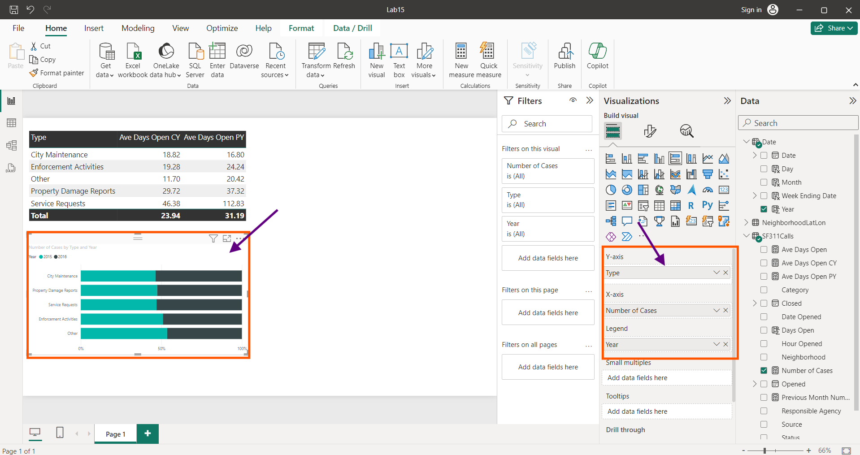

Click the format icon to change the font styles and colour of the Bars.

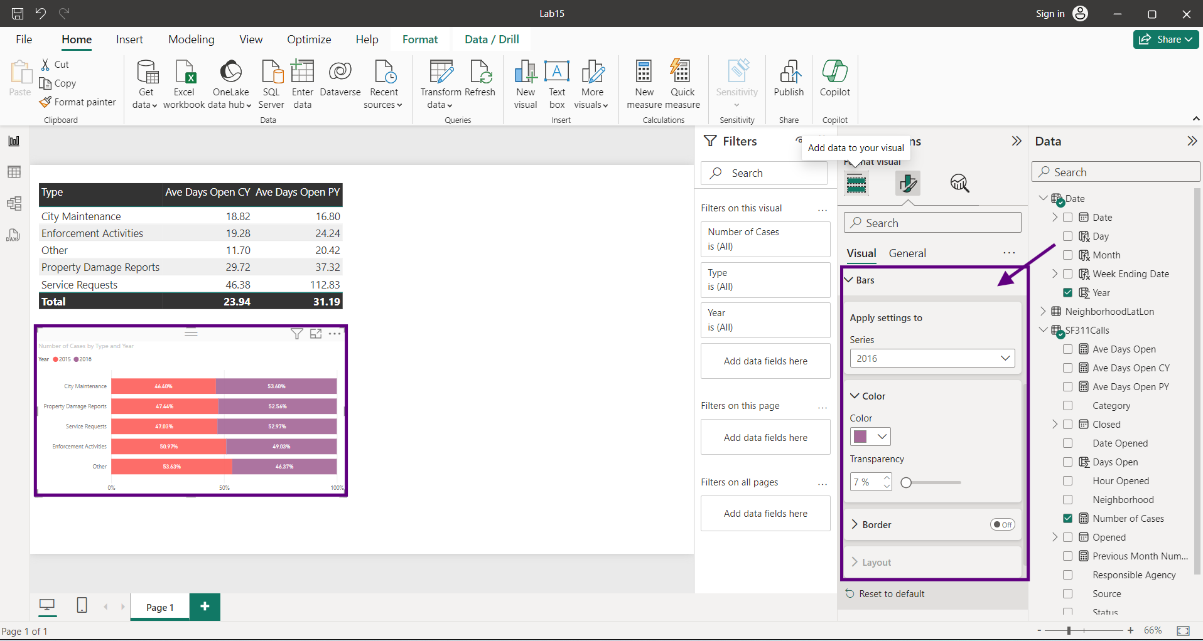

Change the Y axis font and colour as below.

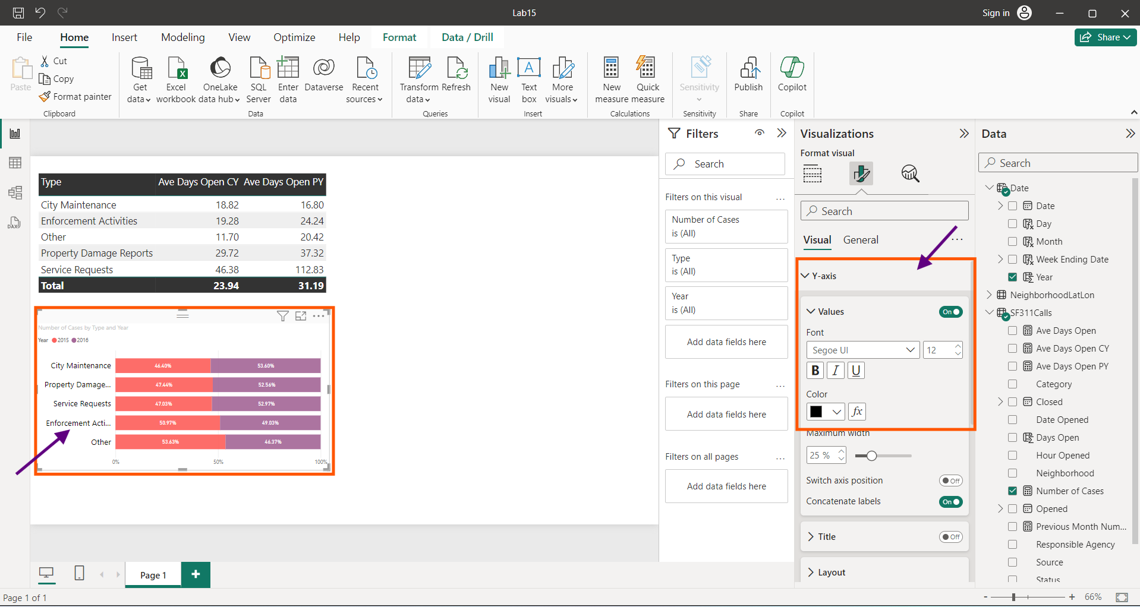

Change the colour and font of X axis as below.

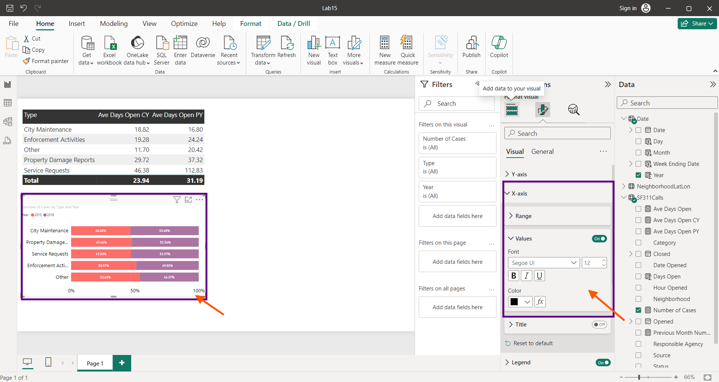

Change the Legend Font and colour.

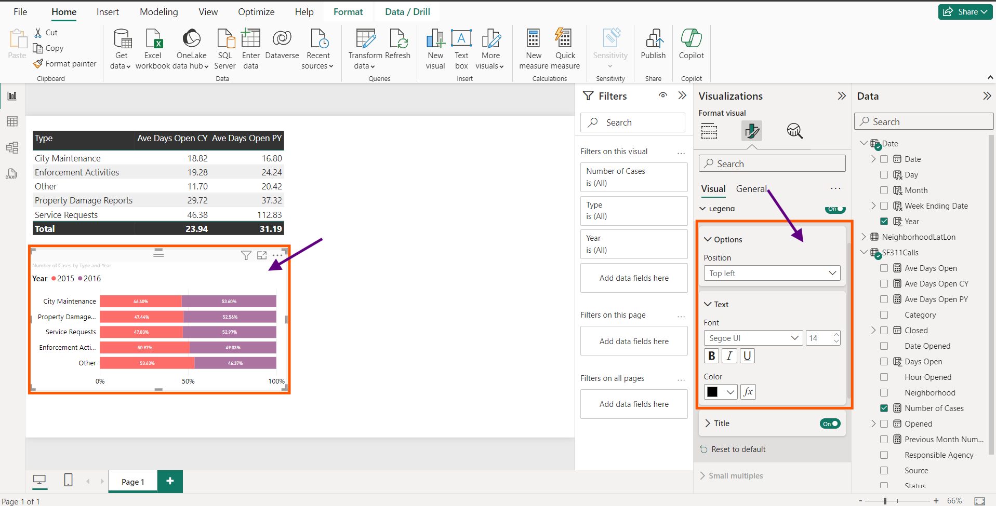

Using Data labels change the following settings under “Details”.

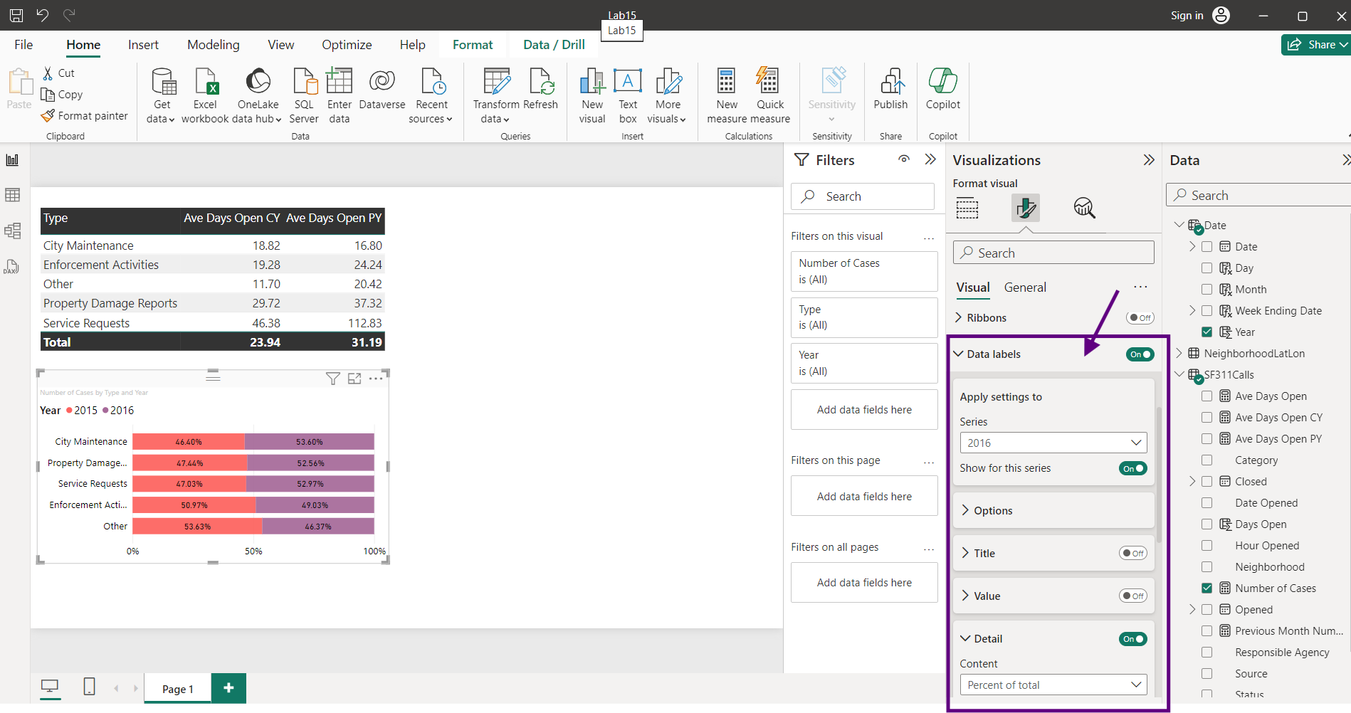

To Change the Title,

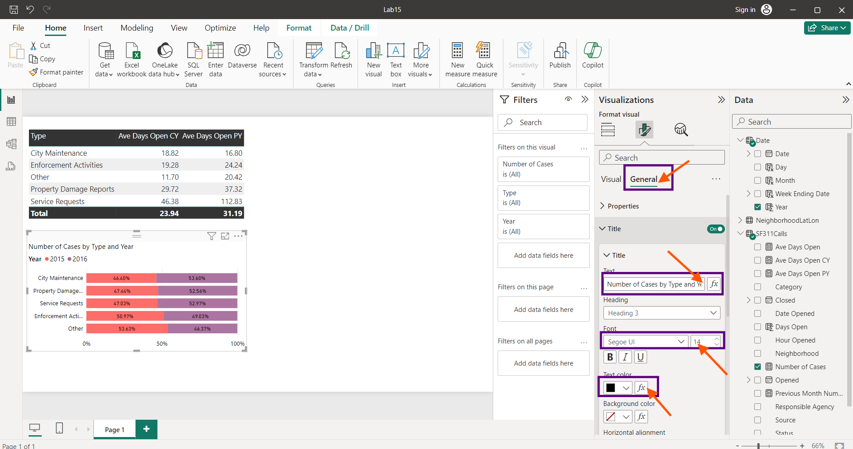

Thus, a clear 100% Stacked bar chart is visualised.

Create a Tree Map by selecting “Neighbour” from NeighbourhoodLatlon table, under Categories Section. “Number of Cases” from SF311Calls table under Values Section. “Avg Days Open” under Tool tips section.

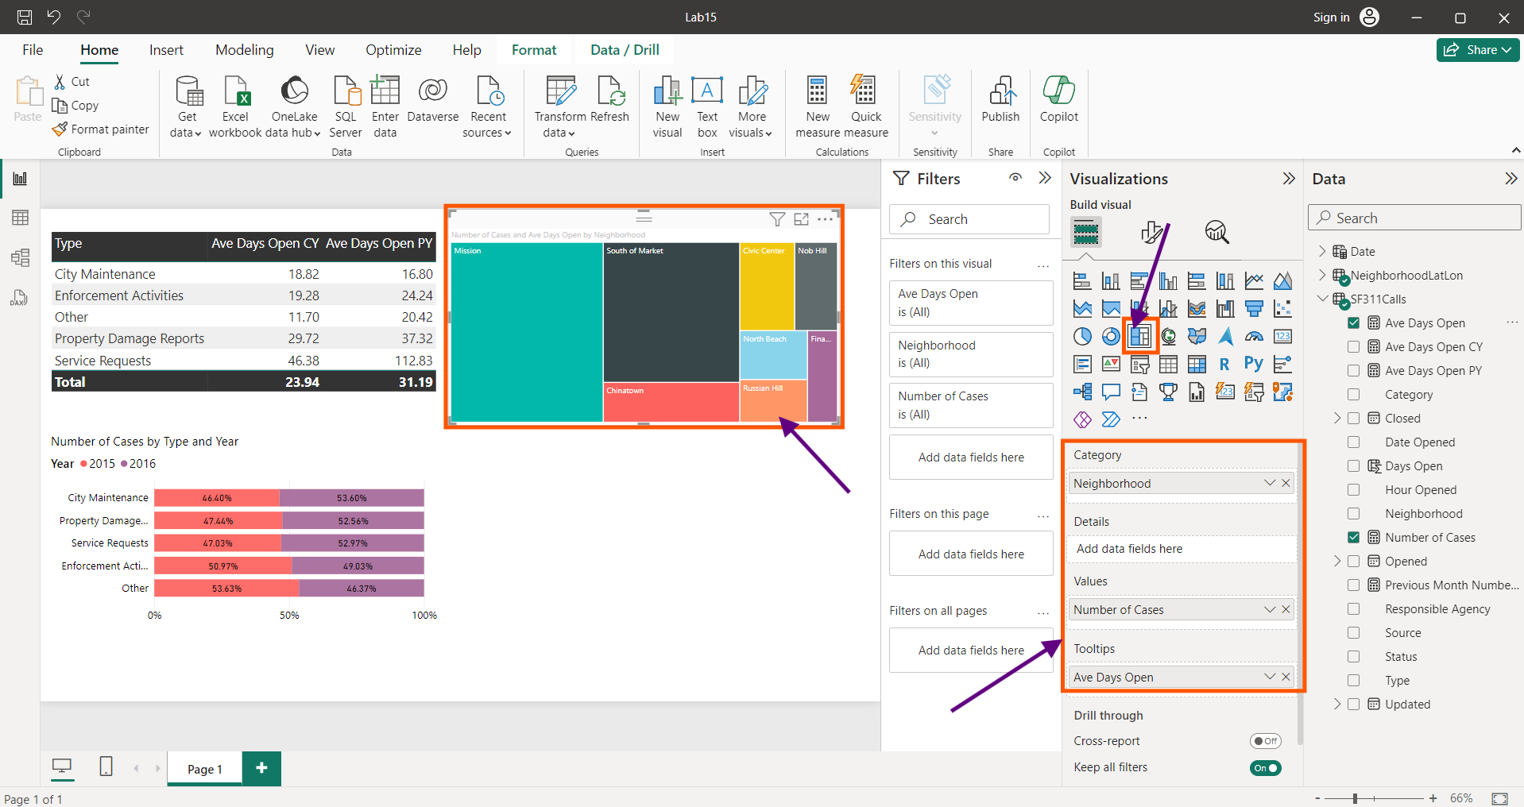

After changing and altering the font size and styles in all the required fields through format icon, we find when we click any region in the map, both our table and bar chart varies accordingly.

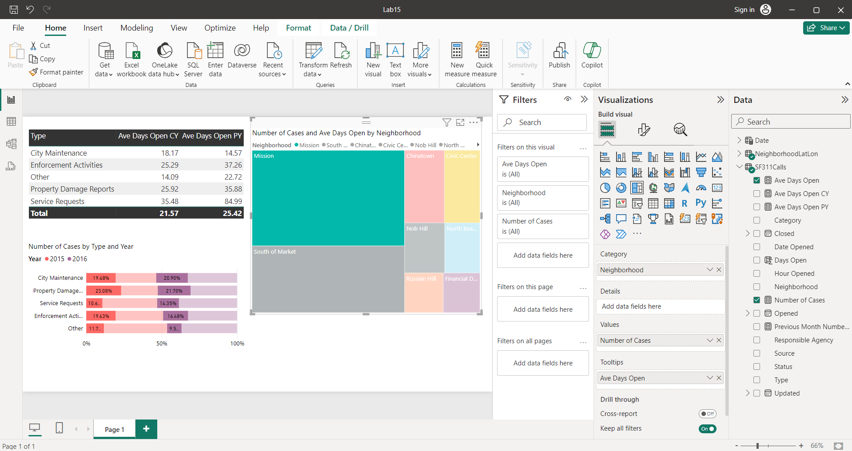

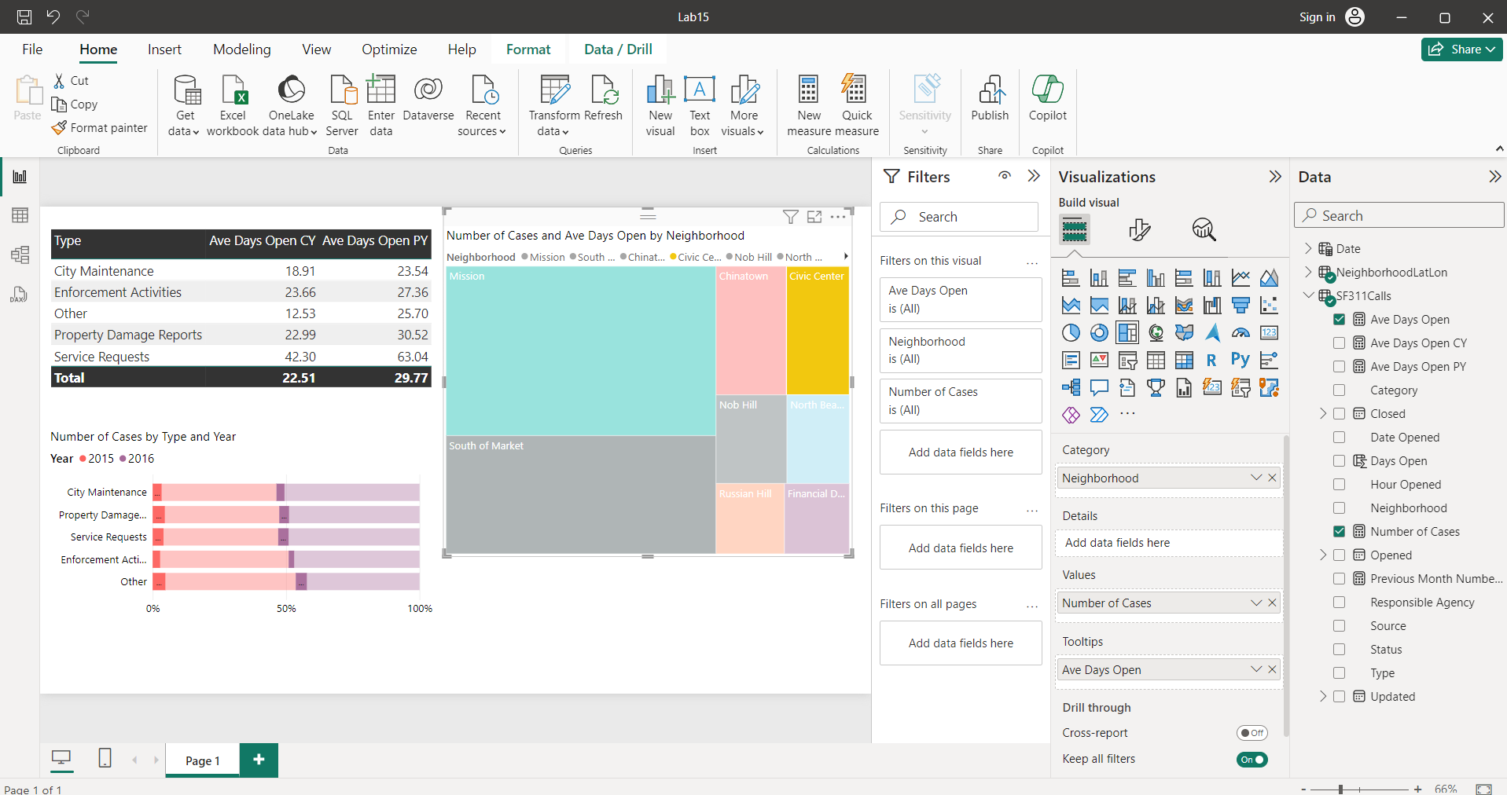

If we wish to have only the bars to vary and the table to remain constant, Click format , Click “Edit Interaction”, Click the button.

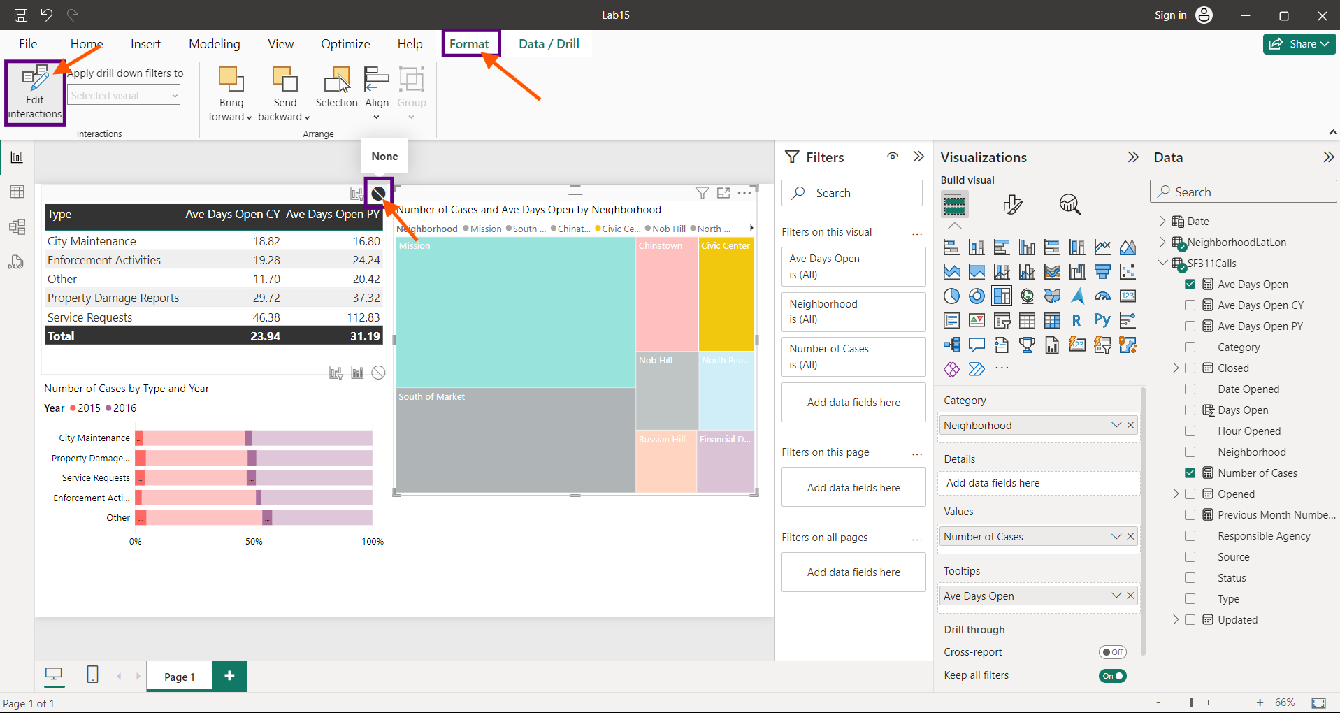

Now, when we click the tree map in any location, we find the table values are constant and the bar values vary.

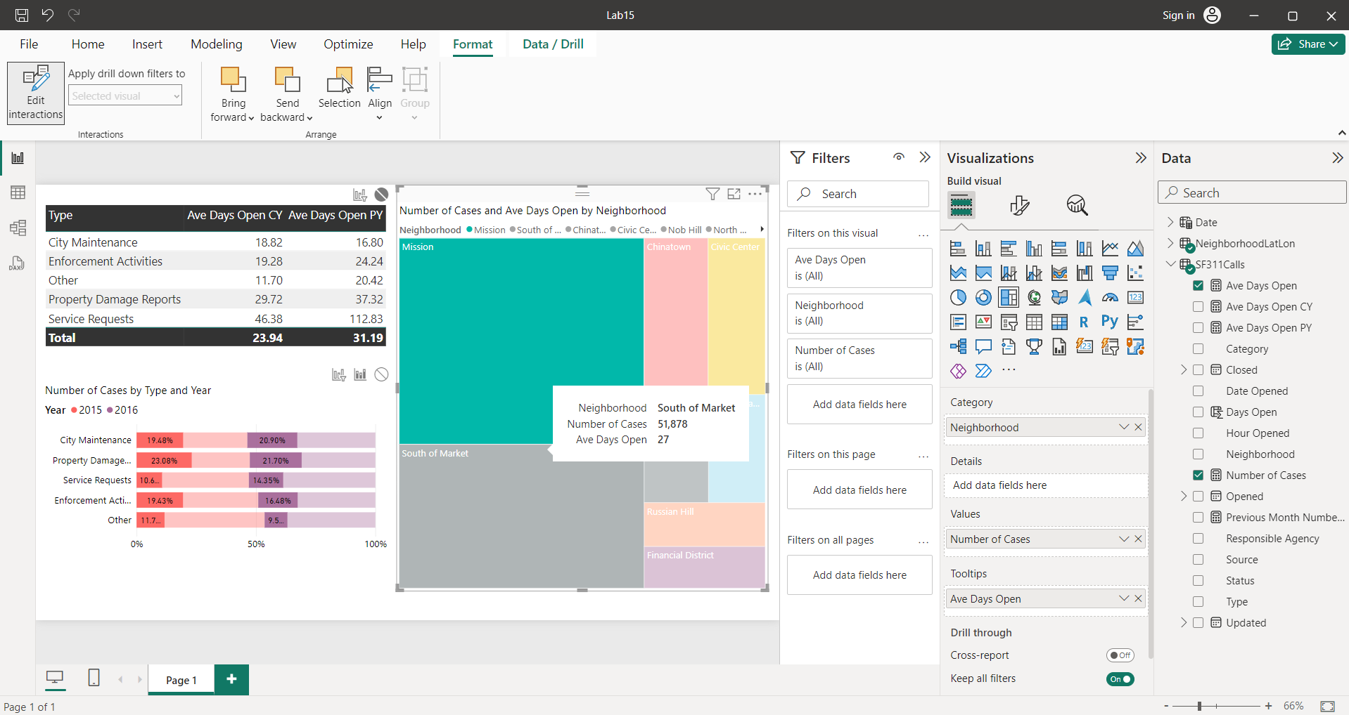

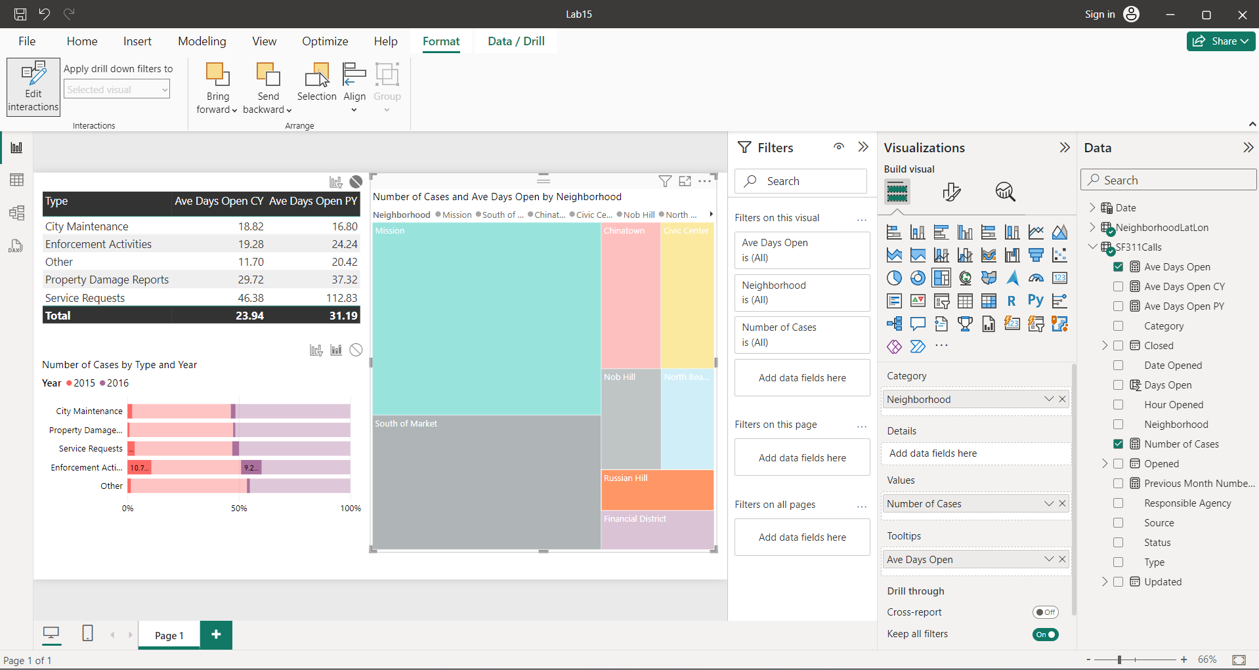

Click the Plus (+) button on the lower right corner of the designer to add a new report page.

Select Line Chart,

Drag and drop “Week Ending Date” from the date table to “X-Axis”. Since “Week Ending Date” is a hierarchy, click the small arrow next to it and select only “Week Ending Date”. Drag and drop “Number of Cases” from SF311Calls table to “Y-Axis”. Enlarge the Graph and adjust the font style , size and colour using Format option. Insert a slicer.

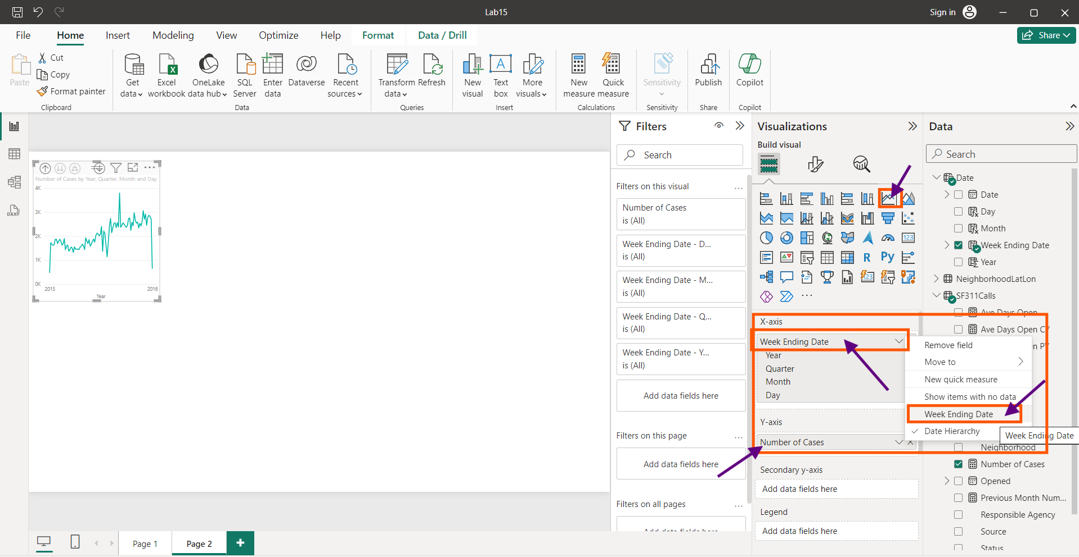

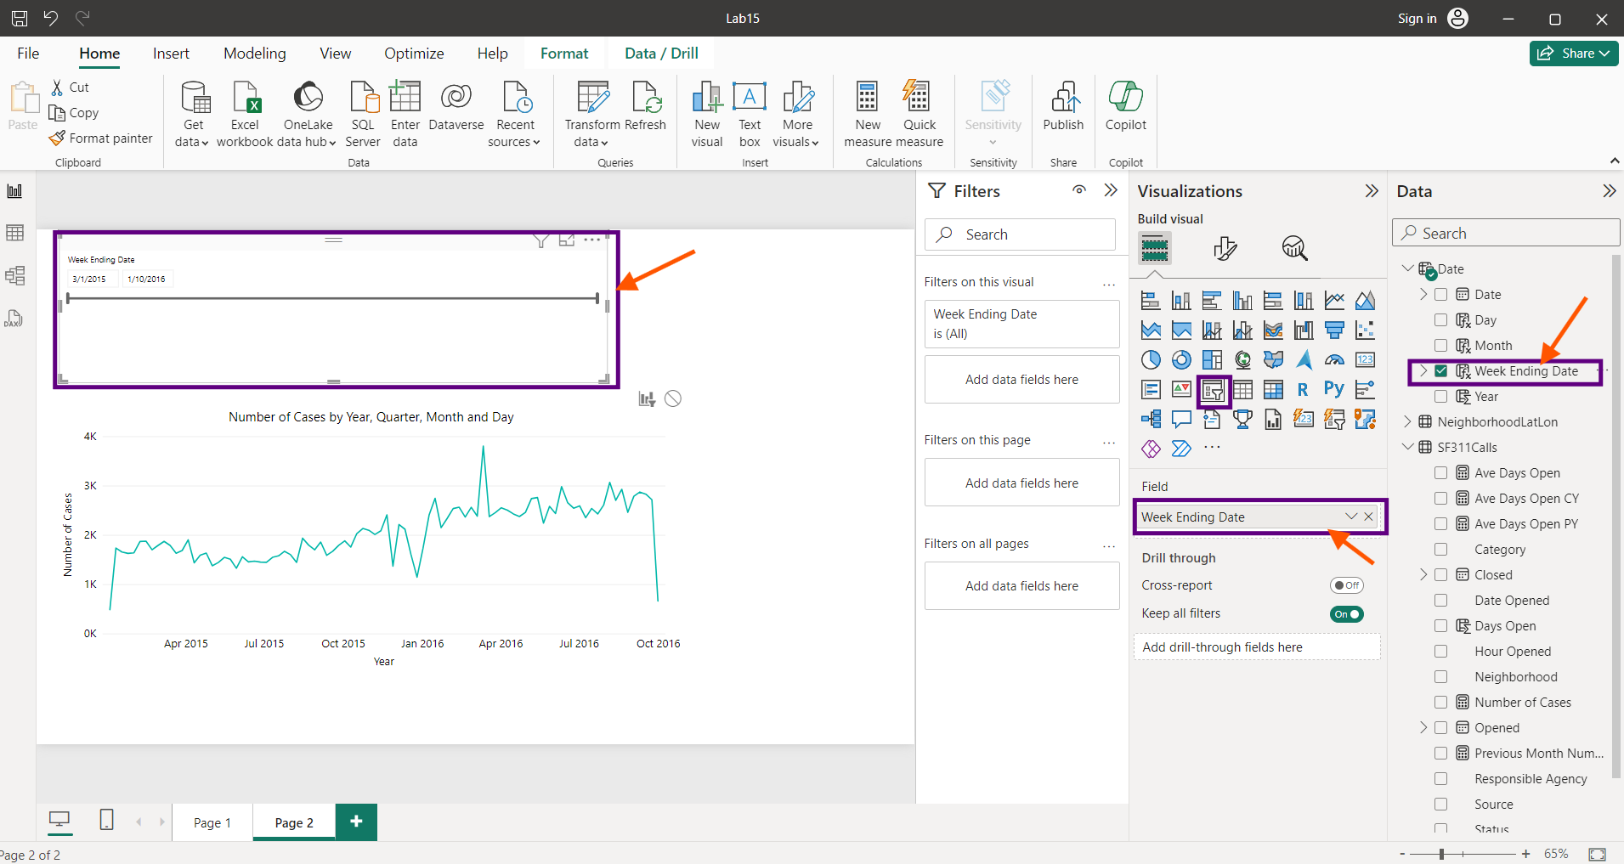

If we vary the slicer, The time period varies, and the graph varies, to add the trending line, Click the “Analytics” icon and switch ON the trending line.

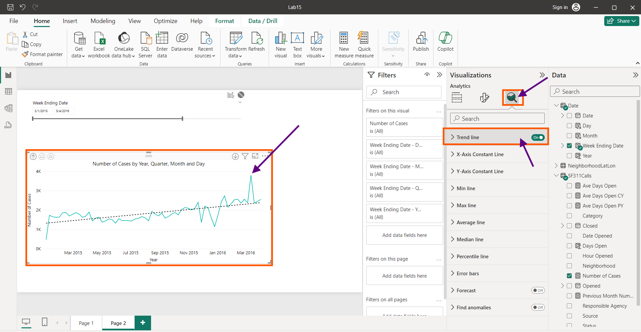

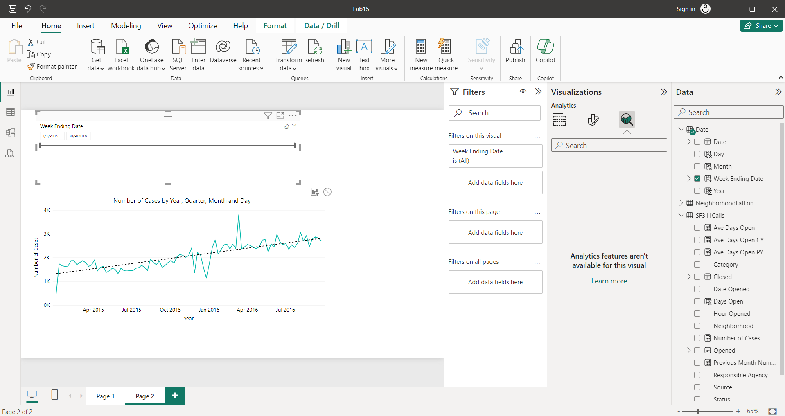

Click plus button (+) to add a new chart.

Click Map button, Drag and Drop “Lattitude” and “Longitude” values from “Neighbourhood” table under “Lattitude” and “Longitude” section. Drag and drop “Neighbourhood” into “Legend” section, “Number of Cases” into “Bubble Size” section.

After changing the Font style and size we get the final map.

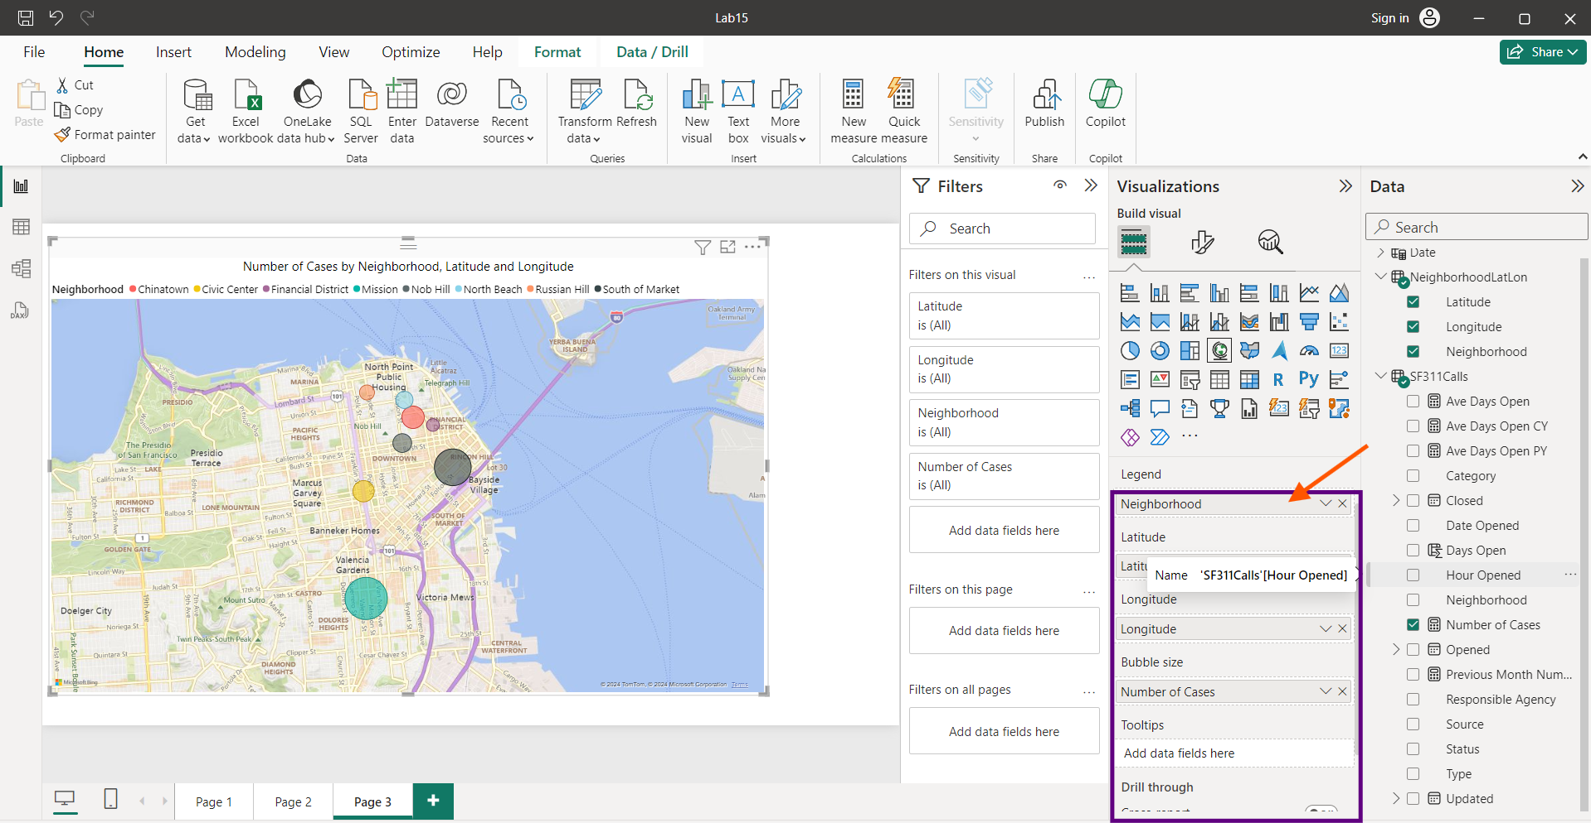

https://blog.coupler.io/power-bi-conditional-formatting/#:~:text=Once%20your%20data%20is%20available%20in%20Power%20BI%2C,the%20typ

* [*The beauty of data visualisation* - David McCandless Links to an external site.](https://www.youtube.com/watch?v=5Zg-C8AAIGg)by TED-Ed